COON VALLEY LUTHERAN CHURCH
“We are a family of God, striving to enrich
the lives of all through the love of Christ.”

PRELUDE MUSIC Mary Schultz
~ GATHERING ~
The Holy Spirit calls us together as the people of God

WELCOME and ANNOUNCEMENTS

CALL to WORSHIP and PRAYER OF CONFESSION
A voice calls out in the wilderness.
It sings of a home for all.
It speaks of justice and peace.
We could choose to ignore it.
We could drown out that song.
We could choose not to listen.
Instead, we come into this space.
We let the world grow quiet.
We listen.
A voice calls out in the wilderness.
Do you hear it?
We hear it. In listening, we worship.
Let us draw near to God.

Expansive God,
We know that the church is your house, and your house has room for everyone. Yet, too often, instead of setting the table for our neighbors,
we block the door.
Instead of welcoming all, we judge others by our own standards.
Instead of sharing our second coat, we hide it in the attic, holding on to fear instead of letting go with love.
Remind us that your home is a home for all, that truth requires hard work, that truth requires uncomfortable justice.
Help us to be bold enough to see it and brave enough to live it.
With hope we pray, amen.

PROCLAMATION of FORGIVENESS
Family of faith, God sent prophets like John the Baptist to us
because this work is not easy. Helping create a world where all might have a home, and all might be loved, and all might know peace, is an audacious goal. Fortunately for us when we mess up—when we lose our way or forget our call—we are met with grace. God could not love us any more or any less than God already does. So rest in this good news: We are at home with God—forgiven, claimed, and loved. The door is always open for us.
Thanks be to God. Amen.

LIGHTING the JOY CANDLE
Joy is seeing people you love after months apart.
Joy is hearing, “Come on over, it has been too long!”
Joy is the stretches and giggles of a newborn child.
Joy is making it home when the journey is long.
Joy is your dog sliding to meet you at the door.
Joy is the energy of a new season.
Joy is feeling found when you thought you were lost.
So today we light the candle of joy, because the welcome God has for us is nothing short of joyful.
Rest in that good news. Let it wash over you.
Family of faith, we are close to home. Amen.

PIANO SOLO The King Shall Come Mary Schultz
~ WORD ~
God speaks to us in scripture reading, preaching, and song

SCRIPTURE READINGS:
Zephaniah 3:14-20
Isaiah 12:2-6
GOSPEL: Luke 3:7-18
The Word of the Lord. Thanks be to God.

SERMON

HYMN of the DAY SOLO Awake! Awake and Greet the New Morn! Mary Schultz

~ RESPONSE TO THE WORD ~
The Holy Spirit calls us as a community to say what we believe,
reach out to each other, and offer gifts and prayers for God’s purposes

PRAYERS of INTERCESSION
Lord, in your mercy…hear our prayer.

OFFERING/OFFERTORY PRAYER
God who welcomes us home, who creates space,
who leaves a chair with our name on it—
we have two coats and we are giving one away.
That’s what this offering is. It is our second coat.
It is our hearts on our sleeves. It is our audacious hope
that there can indeed be a better world the one we often see.
Receive these gifts and use them to move us closer to that promised day.
Gratefully we pray, amen.

THE GREAT THANKSGIVING
The Lord be with you. And also with you.
Lift up your hearts. We lift them to the Lord.
Let us give thanks to the Lord our God.
It is right to give him thanks and praise.

WORDS of INSTITUTION

THE LORD’S PRAYER
Our Father who art in heaven, hallowed be thy name, thy kingdom come, thy will be done, on earth as it is in heaven.
Give us this day our daily bread; and forgive us our trespasses,
as we forgive those who trespass against us;
and lead us not into temptation, but deliver us from evil.
For thine is the kingdom, and the power, and the glory,
forever and ever. Amen.

COMMUNION

SOLO On Jordan’s Bank the Baptist’s Cry Mary Schultz

POST COMMUNION BLESSING and PRAYER

~ SENDING ~
God blesses us and sends us in mission to the world
BLESSING

BELLS

SENDING HYMN ELW #248 People Look East
DISMISSAL

POSTLUDE Mary Schultz
000000 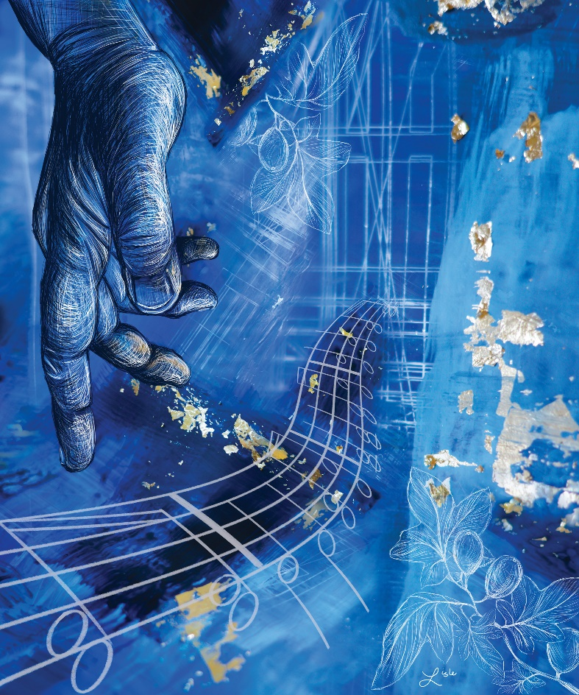00000 0000
“Gather Us In”
by Rev. Lisle Gwynn Garrity
Inspired by Zephaniah 3:14-20

COON VALLEY LUTHERAN CHURCH
Sunday, December 12, 2021
Advent 3

Head Usher: 8:00/Mike Lusk
Altar Guild: 8:00/Karen McGarvey; 10:30/Kari Buros, Julie Nelson, Bella Grethel
Communion Servers: 8:00/Glen Hoff; 10:30/Sarah Ofte
Readers: 8:00/Steve Pauloski; 10:30/Frank Mathison
Attendance December 5: 8a/47; 10:30/39 = 86 total
Offering December 5: $11,700.10
Sunday School Attendance last week: 19

Schedule

TODAY: 9:00a/Sunday School; 9:15a/Bible Study; Giving Tree Gifts Due

MONDAY: Pastor Julie’s Sabbath; 6:00p/Finance Committee; Carillon Deadline

TUESDAY: 1:00p/North Ridge Circle

WEDNESDAY: 5:00p/Confirmation

THURSDAY: 6:00p/Church Council

SATURDAY: 10:00a-Noon/Sunday School Christmas Program practice

NEXT SUNDAY: 10:00a/Sunday School Christmas Program; 9:30/Sunday School

Coon Valley Lutheran Church
www.coonvalleylutheranchurch.org
Pastor: Rev. Julie Wollman, pastorjuliecvlc@gmail.com Home Phone 634-3797
Office Administrator: Jamie Thomas, jamiel@mwt.net
Office Hours: Tuesday 9:00a-2:30p; Wednesday & Thursday 9:00a-4:00p
Office 452-3772/Cell 317-0007
Treasurer: Becky Lusk, treasurer1005@mwt.net
Organist: Mary Schultz
Indoor Custodian: Tracy Stellner

FIRST READING: ZEPHANIAH 3:14-20
Sing aloud, O daughter Zion; shout, O Israel! Rejoice and exult with all your heart, O daughter Jerusalem! The LORD has taken away the judgments against you, he has turned away your enemies. The king of Israel, the LORD, is in our midst; you shall fear disaster no more. On that day it shall be said to Jerusalem: Do not fear, O Zion; do not let your hands grow weak. The LORD, your God, is in your midst, a warrior who gives victory; he will rejoice over you with gladness, he will renew you in his love; he will exult over you with loud singing as on a day of festival. I will remove disaster from you, so that you will not bear reproach for it. I will deal with all your oppressors at that time. And I will save the lame and gather the outcast, and I will change their shame into praise and renown in all the earth. At that time I will bring you home, at the time when I gather you; for I will make you renowned and praised among all the peoples of the earth, when I restore your fortunes before your eyes, says the LORD.
The Word of the Lord. Thanks be to God.

SECOND READING: ISAIAH 12:2-6
Surely God is my salvation; I will trust, and will not be afraid, for the LORD GOD is my strength and my might; he has become my salvation. With joy you will draw water from the wells of salvation. And you will say in that day: Give thanks to the LORD, call on his name; make known his deeds among the nations; proclaim that his name is exalted. Sing praises to the LORD, for he has done gloriously; let this be known in all the earth. Shout aloud and sing for joy, O royal Zion, for great in your midst is the Holy One of Israel.
The Word of the Lord. Thanks be to God.

GOSPEL READING: LUKE 3:7-18
John said to the crowds that came out to be baptized by him, “You brood of vipers! Who warned you to flee from the wrath to come? Bear fruits worthy of repentance. Do not begin to say to yourselves, ‘We have Abraham as or ancestor’; for I tell you, God is able from these stones to raise up children to Abraham. Even now the ax is lying at the root of the trees; every tree therefore that does not bear good fruit is cut down and thrown into the fire.” And the crowds asked him, “What then should we do?” In reply he said to them, “Whoever has two coats must share with anyone who has none; and whoever has food must do likewise.” Even tax collectors came to be baptized, and they asked him, “Teacher, what should we do?” He said to them, “Collect no more than the amount prescribed for you.” Soldiers also asked him, “And we, what should we do?” He said to them, “Do not extort money from anyone by threats or false accusation, and be satisfied with your wages.” As the people were filled with expectation, and all were questioning in their hearts concerning John, whether he might be the Messiah, John answered all of them by saying, “I baptize you with water; but one who is more powerful than I is coming; I am not worthy to untie the thong of his scandals. He will baptize you with the Holy Spirit and fire. His winnowing fork is in his hand, to clear his threshing floor and to gather the wheat into his granary; but the chaff he will burn with unquenchable fire.” So, with many other exhortations, he proclaimed the good news to the people.
The Word of the Lord. Thanks be to God.

*We are always so happy to include you and our CVLC family in our prayers. If you feel your name, or the name of a family member can be removed from this list please contact Jamie. Thank you!

We remember in prayer:
† Those hospitalized this past week: Alice Marie Sather
† Our members whose names we lift up in prayer today: Randy Amundson, Beverly Bagstad, Eleanor Bagstad, Tip Bagstad, Clifford Bakkum, Inez Beck, Kristin Boettcher, Ellie Brye, Chris Cabe, Kim Cade, Jeanne Ebli, Kira Foster, Lucy Hardie, Bonnie Holey, Becky Ihle, Verlin Ihle, Jim Knutson, Paul Kogut, Margaret Lee, Russell Lee, Aaron Leisso, Gerri Leum, Larry Lichtie, Cindy Manske, Aaron Marx, Frank Mathison, Judy Mathison, Skyler Midtlien, Bud Miyamoto, Romaine Nelson, Sandy Nelson, Cathy Ofte, Lisa Olson, Pam Pauloski, Eunice Quast, Jojo Satona, Mary Schultz, Billie Slater, LaVonne Stendahl, Floyd Storey, Nancy Stuempges, Joyce Temp, Lanny Westphal, Renita Williamson
† Our members who are currently in health care facilities: Rachel Berg, Evelyn Dahlen, Joanne Fletcher, Erma Graupe, Sylvester King Jr., Irene Larson, Glen Marshall, Irene Nestingen, Tim Ofte, Beatrice Olson (Alden), Beatrice Olson (Leonard), Betty Sanders, Alice Marie Sather, Arlene Townsend.
† Those who grieve: Family of Roger Olson; Family of Ray Sedevie; Family and friends of Burton Lee; Family and friends of Valarie Holey; Family and friends of Tiffany Rundhaugen
† Our members who are currently home-bound
† All those in need of God’s healing and help
† Family and friends of our members
† All those affected by recent floods
† All those affected by the COVID-19 virus

Coon Valley Lutheran Church
Announcements for December 12, 2021
Good morning and welcome to worship!

~Please note: Pastor Julie has a new email address! pastorjuliecvlc@gmail.com

~Please note: On Sunday, December 19th our Sunday School Christmas Program will be at 10:00am! Parents: Please have Sunday School children at the church on Saturday Dec. 18 for practice from 10am-Noon. Also, please have children arrive on Sunday Dec. 19th at 9:30.am.

Christmas Worship Opportunities

Christmas Eve: 4:00pm Candlelight worship

Christmas Day: 9:00am worship with Holy Communion

December 26th 9:00am worship with a video recorded sermon provided by Bishop Felix Malpica

~Offering envelopes are available. They are located on a table in the Dining Room. Please pick them up for family, friends or neighbors!

~2021 offering deadline. The last day to get offerings to the church to be counted on your 2021 giving statement is Tuesday, December 28th at 9:30am. Thank you for your generosity and support!

~Giving Tree: Today is the last day to drop off gifts for our Giving Tree!

~Our council has adopted new guidelines regarding our Coronavirus precautions. Masks are required for all even if you are vaccinated. We will be singing one hymn at the end of each service, following the Benediction. If you wish to leave after the Benediction and prior to the singing of the hymn, please feel welcome to do so. Also, at this time all food service, including coffee fellowship is cancelled until infection rates are lowered. Thank you!

~ Please sign up for Kwik Trip gift cards. Youth Mission Trip Fund will get 5% off the purchase price. Cards are ordered at the end of the month and will be available for pickup after Sunday services or by coming to the office during office hours. Contact Jamie for more information. This is an easy way for our Youth to earn money toward the ELCA Youth Gathering and future mission trips! Please find sign-up sheets in the Narthex and by Jamie’s office.

~Join us for Bible Study in-person OR online! Today is the last Bible Study, please join! Dan Wollman will be leading a Bible Study on the Bible’s first book of Genesis. All are welcome for this time of fellowship, learning, and sharing! The Bible Study will begin on November 7 and be held for six Sundays, from 9:15 a.m. until 10:00 a.m. To meet with us in person, please join us in the upstairs Library/Lounge area. If you would like to join us via Zoom, please contact Pastor Julie with your email address by Tuesday, November 2. A Zoom link will then be sent to you via email. You are welcome to bring your own Bible to the study or one will be provided for you. We hope to see you there!

~CVLC is pleased to announce we have an upgraded mobile app! Vanco, our eGiving provider, has launched an updated mobile app called Vanco Mobile. This new mobile app will be replacing GivePlus Mobile. With Vanco Mobile, you can send one-time donations or set recurring gifts.
How Do You Download Vanco Mobile?
It’s easy! Head over to the App Store or Google Play to download Vanco Mobile for free. Be sure to download this app soon, as GivePlus Mobile will be retired as of January 31, 2022.
Turn over for more announcements
To give using Vanco Mobile, follow these five easy steps:
- Search for our church by name.
- Select your gift amount, fund and frequency.
- Enter your payment method. (You can save this information for future use!)
- Choose whether you want to cover processing fees.
- Click Submit to complete your donation.
You can also check out the handouts located at the kiosk in the narthex for step-by-step instructions. Please stop by the church office or call Jamie if you have questions or need assistance.

