COON VALLEY LUTHERAN CHURCH
“We are a family of God, striving to enrich
the lives of all through the love of Christ.”
Sunday, November 28, 2021
9:00 a.m.
PRELUDE MUSIC Mary Schultz

~ GATHERING ~
The Holy Spirit calls us together as the people of God
WELCOME and ANNOUNCEMENTS

Call to Worship
Can one be homesick for something you’ve never known?
We are homesick for a just world,
for peace like rivers,
for the end of suffering.
Yes, we are homesick—
for joy that is contagious,
for nations that feel like neighbors,
and for hospitals that run empty.
We are homesick for the world God promises.
We are homesick, but we are on our way.
God is here. God is still creating.
Let us worship Holy God.

Candle Lighting Liturgy
We hope for a world where all are fed.
We hope for a world with wide open doors.
We hope for a world with contagious laughter.
We hope for a world where trees grow tall and creeks run clean.
We hope for a world where all people feel at home—in their bodies, in the church, in their physical homes.
We hope for that world.
We long for that world.
So today we light the candle of hope, because hope keeps our hearts alive as we wait.
May this light be a reminder that the wait is always worth it.
We are close to home. May we carry hope with us. Amen.

Prayer of the Day
God of the stars and God of our hearts— our days will pass but your words will last. The earth might fade but your words will last. Our memories might blur but your words will last. The grass will wither but your words will last. The sky could go dark and your words would last. So as we listen today, help us to hold onto what will last. Help us hold onto you. Gratefully we pray, amen.

SOLO Wake, Awake for Night is Flying Mary Schultz

~ WORD ~ (Scripture insert)
God speaks to us in scripture reading, preaching, and song
FIRST READING: Jeremiah 33:14-16
PSALM 25:1-10 (Read Responsively)
SECOND READING: 1 Thessalonians 3:9-13
GOSPEL: Luke 21:25-36

SERMON

HYMN of the Day SOLO O Come, O Come, Emmanuel Mary Schultz

~ RESPONSE TO THE WORD ~
The Holy Spirit calls us as a community to say what we believe,
reach out to each other, and offer gifts and prayers for God’s purposes

THE APOSTLES’ CREED
I believe in God, the Father Almighty,
Creator of Heaven and earth;
I believe in Jesus Christ, God’s only Son Our Lord,
who was conceived by the Holy Spirit,
born of the Virgin Mary,
suffered under Pontius Pilate,
was crucified, died, and was buried;
he descended to the dead.
On the third day he rose again;
he ascended into heaven,
he is seated at the right hand of the Father,
and he will come to judge the living and the dead.
I believe in the Holy Spirit,
the holy catholic church,
the communion of saints,
the forgiveness of sins,
the resurrection of the body,
and the life everlasting. Amen.

PRAYERS OF INTERCESSION
Petitions end: Lord, in your mercy… hear our prayer

THE LORD’S PRAYER
Our Father who art in heaven, hallowed be thy name, thy kingdom come, thy will be done, on earth as it is in heaven.

Give us this day our daily bread; and forgive us our trespasses,
as we forgive those who trespass against us;
and lead us not into temptation,
but deliver us from evil.
For thine is the kingdom, and the power, and the glory,
forever and ever. Amen.

OFFERING and OFFERTORY PRAYER
Holy God, we are homesick. We long for the day that you spoke of when swords will be beaten into plowshares, the lion will lie down with the lamb, and justice will roll like waters. Until that holy day comes, receive these gifts as signs of our hope and use them to build that world here. In Jesus’ name we pray, Amen.
~ SENDING ~
God blesses us and sends us in mission to the world
BLESSING

BELLS

SENDING SONG ELW#244 Rejoice, Rejoice Believers

DISMISSAL
Go in peace. Serve the Lord. Thanks be to God.
Postlude Mary Schultz

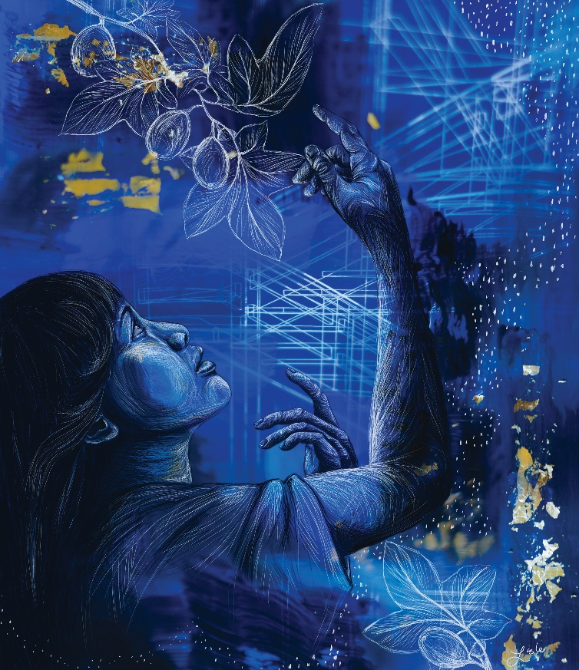
“Awake to Wonder”
By Rev. Lisle Gwynn Garrity
Inspired by Luke 21:25-36

The First Sunday in Advent: Hope
Coon Valley Lutheran Church
November 28, 2021

~Bulletins are in memory of Casey McNamer from Jason & Jamie Thomas & family

Head Usher:
Reader: Jan Bender
Attendance & Offering November 21: 8a/43; 10:30/20=63 $2,117.71
Sunday School Attendance November 21: 16

Schedule

MONDAY: Pastor Julie’s Sabbath

WEDNESDAY: 5:00p/Confirmation

THURSDAY: 3:00p/Rebecca Circle Christmas Party

SATURDAY: 2:00-6:30p/Road to Bethlehem-Sugar Creek

NEXT SUNDAY: 8:00 & 10:30/Worship with Holy Communion; 9:00/Sunday School; 9:00/Stewardship Committee; 9:15/Bible Study

Coon Valley Lutheran Church
www.coonvalleylutheranchurch.org
Pastor: Rev. Julie Wollman, pastorjuliecvlc@gmail.com Home Phone 634-3797
Office Administrator: Jamie Thomas, jamiel@mwt.net
Office Hours: Tuesday 9:00a-2:30p; Wednesday & Thursday 9:00a-4:00p
Office 452-3772/Cell 317-0007
Treasurer: Becky Lusk, treasurer1005@mwt.net
Organist: Mary Schultz
Indoor Custodian: Tracy Stellner

FIRST READING: JEREMIAH 33:14-16
The days are surely coming, says the LORD, when I will fulfill the promise I made to the house of Israel and the house of Judah. In those days and at that time I will cause a righteous Branch to spring up for David; and he shall execute justice and righteousness in the land. In those days Judah will be saved and Jerusalem will live in safety. And this is the name by which it will be called: “The LORD is our righteousness.”
The Word of the Lord. Thanks be to God.

PSALM 25: 1-10(read responsively)
To you, O LORD, I lift up my soul.
O my God, in you I trust; do not let me be put to shame; do not let my enemies exult over me.
Do not let those who wait for you be put to shame; let them be ashamed who are wantonly treacherous.
Make me to know your ways, O LORD; teach me your paths.
Lead me in your truth, and teach me, for you are the God of my salvation; for you I wait all day long.
Be mindful of your mercy, O LORD, and of your steadfast love, for they have been from of old.
Do not remember the sins of my youth or my transgressions; according to your steadfast love remember me, for your goodness’ sake, O LORD!
Good and upright is the LORD; therefore he instructs sinners in the way.
He leads the humble in what is right, and teaches the humble his way.
All the paths of the LORD are steadfast love and faithfulness, for those who keep his covenant and his decrees.

SECOND READING: 1 THESSALONIANS 3:9-13
How can we thank God enough for you in return for all the joy that we feel before our God because of you? Night and day we pray most earnestly that we may see you face to face and restore whatever is lacking in your faith. Now may our God and Father himself and our Lord Jesus direct our way to you. And may the Lord make you increase and abound in love for one another and for all, just as we abound in love for you. And may he so strengthen your hearts in holiness that you may be blameless before our God and Father at the coming of our Lord Jesus with all his saints.
The Word of the Lord. Thanks be to God.

GOSPEL READING: LUKE 21:25-36
Jesus said: “There will be signs in the sun, the moon, and the stars, and on the earth distress among nations confused by the roaring of the sea and the waves. People will faint from fear and foreboding of what is coming upon the world, for the powers of the heavens will be shaken. Then they will see ‘the Son of Man coming in a cloud’ with power and great glory. Now when these things begin to take place, stand up and raise your heads, because your redemption is drawing near.” Then he told them a parable: “Look at the fig tree and all the trees; as soon as they sprout leaves you can see for yourselves and know that summer is already near. So also, when you see these things taking place, you know that the kingdom of God is near. Truly I tell you, this generation will not pass away until all things have taken place. Heaven and earth will pass away, but my words will not pass away. “Be on guard so that your hearts are not weighed down with dissipation and drunkenness and the worries of this life, and that day does not catch you unexpectedly, like a trap. For it will come upon all who live on the face of the whole earth. Be alert at all times, praying that you may have the strength to escape all these things that will take place, and to stand before the Son of Man.”
The Word of the Lord. Thanks be to God.

*We are always so happy to include you and our CVLC family in our prayers. If you feel your name, or the name of a family member can be removed from this list please contact Jamie. Thank you!

We remember in prayer:
† Those hospitalized this past week: Pam Pauloski, Kim Cade
† Our members whose names we lift up in prayer today: Randy Amundson, Beverly Bagstad, Eleanor Bagstad, Tip Bagstad, Clifford Bakkum, Inez Beck, Kristin Boettcher, Ellie Brye, Chris Cabe, Jeanne Ebli, Kira Foster, Lucy Hardie, Bonnie Holey, Becky Ihle, Verlin Ihle, Jim Knutson, Paul Kogut, Margaret Lee, Russell Lee, Aaron Leisso, Gerri Leum, Larry Lichtie, Cindy Manske, Aaron Marx, Frank Mathison, Judy Mathison, Skyler Midtlien, Bud Miyamoto, Romaine Nelson, Sandy Nelson, Cathy Ofte, Lisa Olson, Pam Pauloski, Jeremy Pratt, Eunice Quast, Jojo Satona, Mary Schultz, Billie Slater, LaVonne Stendahl, Floyd Storey, Nancy Stuempges, Joyce Temp, Lanny Westphal, Renita Williamson
† Our members who are currently in health care facilities: Rachel Berg, Evelyn Dahlen, Joanne Fletcher, Erma Graupe, Sylvester King Jr., Irene Larson, Glen Marshall, Irene Nestingen, Tim Ofte, Beatrice Olson (Alden), Beatrice Olson (Leonard), Betty Sanders, Arlene Townsend.
† Those who grieve: Family of Ray Sedevie; Family and friends of Burton Lee; Family and friends of Valarie Holey; Family and friends of Tiffany Rundhaugen
† Our members who are currently home-bound
† All those in need of God’s healing and help
† Family and friends of our members
† All those affected by recent floods
† All those affected by the COVID-19 virus

Coon Valley Lutheran Church
Announcements for November 28, 2021
Good morning and welcome to worship!

~Please note: Pastor Julie has a new email address! pastorjuliecvlc@gmail.com

~Please note: On Sunday, December 19th our Sunday School Christmas Program will be at 10:00am!

~2021 offering deadline. The last day to get offerings to the church to be counted on your 2021 giving statement is Tuesday, December 28th at 9:30am. Thank you for your generosity and support!

~“The Road to Bethlehem” is being held at Sugar Creek again this year! Celebrate the reason for the season with this drive-through event! The Road to Bethlehem is being held on December 4 from 2:00 p.m. until 6:30 p.m. at Sugar Creek Bible Camp, 13141 Sugar Creek Bible Camp Road, Ferryville, WI.

~Our council has adopted new guidelines regarding our Coronavirus precautions. Masks are required for all even if you are vaccinated. We will be singing one hymn at the end of each service, following the Benediction. If you wish to leave after the Benediction and prior to the singing of the hymn, please feel welcome to do so. Also at this time all food service, including coffee fellowship is cancelled until infection rates are lowered. Thank you!

~This is the last Sunday to order Kwik trip cards before Christmas!

Please sign up for Kwik Trip gift cards. Youth Mission Trip Fund will get 5% off the purchase price. Cards are ordered at the end of the month and will be available for pickup after Sunday services or by coming to the office during office hours. Contact Jamie for more information. This is an easy way for our Youth to earn money toward the ELCA Youth Gathering and future mission trips! Please find sign-up sheets in the Narthex and by Jamie’s office.

~Join us for Bible Study in-person OR online! Dan Wollman will be leading a Bible Study on the Bible’s first book of Genesis. All are welcome for this time of fellowship, learning, and sharing! The Bible Study will begin on November 7 and be held for six Sundays, from 9:15 a.m. until 10:00 a.m. To meet with us in person, please join us in the upstairs Library/Lounge area. If you would like to join us via Zoom, please contact Pastor Julie with your email address by Tuesday, November 2. A Zoom link will then be sent to you via email. You are welcome to bring your own Bible to the study or one will be provided for you. We hope to see you there!

~CVLC is pleased to announce we have an upgraded mobile app! Vanco, our eGiving provider, has launched an updated mobile app called Vanco Mobile. This new mobile app will be replacing GivePlus Mobile. With Vanco Mobile, you can send one-time donations or set recurring gifts.
How Do You Download Vanco Mobile?
It’s easy! Head over to the App Store or Google Play to download Vanco Mobile for free. Be sure to download this app soon, as GivePlus Mobile will be retired as of January 31, 2022.
Turn over for more announcements
To give using Vanco Mobile, follow these five easy steps:
- Search for our church by name.
- Select your gift amount, fund and frequency.
- Enter your payment method. (You can save this information for future use!)
- Choose whether you want to cover processing fees.
- Click Submit to complete your donation.
You can also check out the handouts located at the kiosk in the narthex for step-by-step instructions. Please stop by the church office or call Jamie if you have questions or need assistance.

