COON VALLEY LUTHERAN CHURCH
“We are a family of God, striving to enrich
the lives of all through the love of Christ.”
November 8, 2020 ~ 9:00 A.M.
November 11, 2020 ~ 6:00 P.M.

~ GATHERING ~
The Holy Spirit calls us together as the people of God

PRELUDE Mary Schultz
WELCOME and ANNOUNCEMENTS

CONFESSION and FORGIVENESS
In the name of the Father, and of the Son, and of the Holy Spirit, Amen.

Almighty God, to whom all hearts are open, all desires known, and from whom no
secrets are hid: cleanse the thoughts of our hearts by the inspiration of your Holy Spirit, that we may perfectly love you and worthily magnify your holy name, through
Jesus Christ our Lord. Amen.

Let us confess our sin in the presence of God and of one another.

Most merciful God,
We confess that we are captive to sin and cannot free ourselves. We have sinned
against you in thought, word, and deed, by what we have done and by what we have left undone. We have not loved you with our whole heart; we have not loved our neighbors as ourselves. For the sake of your Son, Jesus Christ, have mercy on us. Forgive us, renew us, and lead us, so that we may delight in your will and walk in your ways, to the glory of your holy name. Amen.

In the mercy of Almighty God Jesus Christ was given to die for us and for his sake forgives us all our sins. As a called and ordained minister of the Church of Christ and by Christ’s authority, I therefore declare to you the entire forgiveness of all your sins. In the name of the Father and of the Son and of the Holy Spirit. Amen.

GREETING
The grace of our Lord Jesus Christ, the love of God, and the communion of the Holy Spirit be with you all.
And also with you.

PRAYER OF THE DAY
Beloved God, from you come all things that are good. Lead us by the inspiration of your Spirit to know those things that are right, and by your merciful guidance, help us to do them, through Jesus Christ, our Savior and Lord. Amen.

(Sunday) PIANO SOLO Soon and Very Soon Mary Schultz
(Wednesday) SOLO Come, Thou Fount of Every Blessing Shianne Reschke
~ WORD ~ (Scripture insert)
God speaks to us in scripture reading, preaching, and song

FIRST READING: 1 Thessalonians 4:13-18
GOSPEL: Matthew 25:10-13
After the Gospel is read
The Gospel of the Lord. Thanks be to God.

SERMON

PIANO SOLO O God, Our Help in Ages Past Mary Schultz

~ RESPONSE TO THE WORD ~
The Holy Spirit calls us as a community to say what we believe,
reach out to each other, and offer gifts and prayers for God’s purposes

PRAYERS of the PEOPLE
Lord, in your mercy…hear our prayer.

OFFERING

OFFERTORY PRAYER
Blessed are you, O God, maker of all things. Through your goodness you have blessed us with these gifts: ourselves, our time, and our possessions. Use us, and what we have gathered, in feeding the world with your love, through the one who gave himself for us, Jesus Christ, our Savior and Lord. Amen.

THE GREAT THANKSGIVING
The Lord be with you. And also with you.
Lift up your hearts. We lift them to the Lord.
Let us give thanks to the Lord our God.
It is right to give him thanks and praise.

WORDS OF INSTITUTION

THE LORD’S PRAYER
Our Father who art in heaven, hallowed be thy name, thy kingdom come, thy will be done, on earth as it is in heaven.
Give us this day our daily bread; and forgive us our trespasses,
as we forgive those who trespass against us;
and lead us not into temptation, but deliver us from evil.
For thine is the kingdom, and the power, and the glory,
forever and ever. Amen.

THE COMMUNION
(Sunday) PIANO SOLO Wake, Awake for Night is Flying Mary Schultz
(Wednesday) SOLO How Great Thou Art Shianne Reschke
POST COMMUNION BLESSING and PRAYER

~ SENDING ~
God blesses us and sends us in mission to the world
BENEDICTION
The Lord bless you and keep you.
The Lord make his face to shine upon you and be gracious to you.
The Lord look upon you with favor, and give you peace. Amen.

BELLS

DISMISSAL
Go in peace. Christ is with you! Thanks be to God!

POSTLUDE Mary Schultz

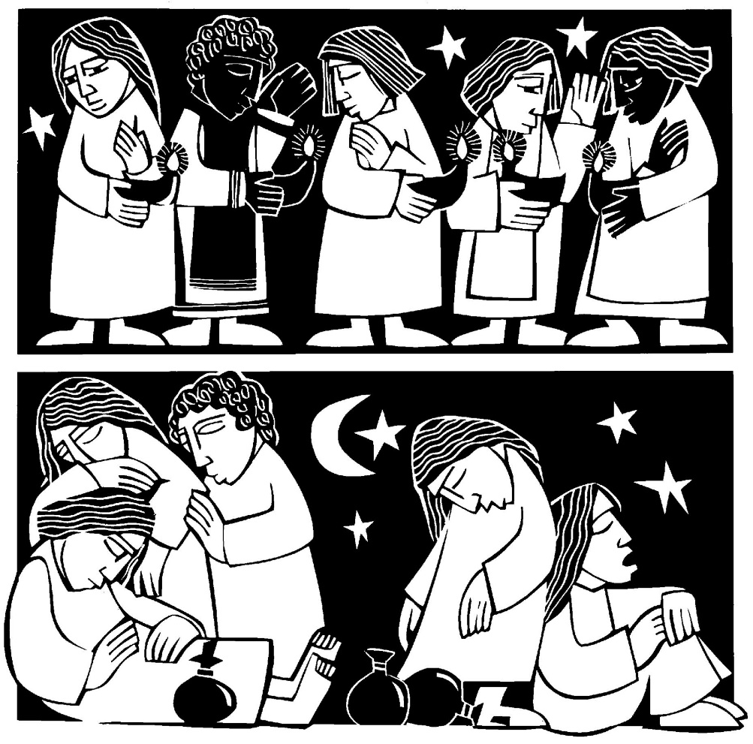

Twenty-Third Sunday in the Season of Pentecost
COON VALLEY LUTHERAN CHURCH
Sunday, October 8, 2020
Wednesday, October 11, 2020

FIRST READING: 1 THESSALONIANS 4:13-18
We do not want you to be uniformed, brothers and sisters, about those who have died, so that you may not grieve as others do who have no hope. For since we believe that Jesus died and rose again, even so, through Jesus, God will bring with him those who have died. For this we declare to you by the word of the Lord, that we who are alive, who are left until the coming of the Lord, will by no means precede those who have died. For the Lord himself, with a cry of command, with the archangel’s call and with the sound of God’s trumpet, will descend from heaven, and the dead in Christ will rise first. Then we who are alive, who are left, will be caught up in the clouds together with them to meet the Lord in the air; and so we will be with the Lord forever. Therefore encourage one another with these words.
The word of the Lord. Thanks be to God.

GOSPEL READING: MATTHEW 25:10-13
And while they went to buy it, the bridegroom came, and those who were ready went with him into the wedding banquet; and the door was shut. Later the other bridesmaids came also, saying, ‘Lord, lord, open to us.’ But he replied, ‘Truly I tell you, I do not know you.’ Keep awake therefore, for you know neither the day nor the hour.
The Gospel of the Lord. Thanks be to God

*We are always so happy to include you and our CVLC family in our prayers. If you feel your name, or the name of a family member can be removed from this list please contact Jamie. Thank you!

We remember in prayer:
† Those hospitalized this past week: Beatrice (Leonard) Olson
† Our members whose names we lift up in prayer today: Beverly Bagstad, Eleanor Bagstad, Tip Bagstad, Clifford Bakkum, Inez Beck, Kay Bjornstad, Evelyn Dahlen, Judy Denison, Jeanne Ebli, Lucy Hardie, Kira Foster, Bonnie Holey, Becky Ihle, Verlin Ihle, Jim Knutson, Elizabeth Larson, Russell Lee, Aaron Leisso, Sarah Leisso, Gerri Leum, Becky Lind, Cindy Manske, Dorothy Marshall, Aaron Marx, Frank Mathison, Skyler Midtlien, Romaine Nelson, Cathy Ofte, Tim Ofte, Sherman Olson, Eunice Quast, Jojo Satona, Aaron Stakston, Terri Stakston, LaVonne Stendahl, Nancy Stuempges, Joyce Temp, Maggie Traastad, Lanny Westphal, Ray Williamson.
† Our members who are currently in health care facilities: Rachel Berg, Erma Graupe, Sylvester King Jr., Irene Larson, Irene Nestingen, Cathy Ofte, Beatrice Olson (Alden), Beatrice Olson (Leonard), Edie Peterson
† Those who grieve: Douglas Bendel & family in the death of his brother Gordon; Kim Hatlan & Family in the death of Kim’s grandmother Ardis Severson; Brian Strangstalien and family in the death of his mother Mary Strangstalien; Family and friends of Orville Stendahl.
† Our members who are currently home-bound
† All those in need of God’s healing and help
† Family and friends of our members
† All those affected by recent floods
† All those affected by the COVID-19 virus

~Bulletins are in honor of the Ruth Circle from Inez Beck.

~We thank all who worship with us today. Please remember to socially distance and wear your mask. Thank you!

~Happy Veterans Day to all our soldiers both past and present!

~A member of our congregation, Jeanne Ebli, is seeking someone to remove snow from her deck, steps and area leading to her deck when the snowfall is more than two inches. Jeanne lives on Highway 162 near Coon Valley. If you are able to assist Jeanne, please call her at 452-3323. Thank you!

Head Usher: Sunday/Jan Bender
Altar Guild: Sunday/Jane Simmons & Gloria Galstad;
Wednesday/Karen McGarvey
Communion Servers: Sunday/Sarah Ofte; Wednesday/Nancy King
Attendance Sunday 10/25: 37; Wednesday 10/28: 23; Offering: $1,851.24

Schedule
SUNDAY: 10:30a-Noon/Confirmation
MONDAY: Pastor Julie’s Sabbath; 9a/WELCA Gen. Board; 6p/Finance Comm.
WEDNESDAY: 6:00p/Worship with Holy Communion
THURSDAY: 6:00p/Church Council
NEXT SUNDAY: 9:00a/Worship
Coon Valley Lutheran Church
www.coonvalleylutheranchurch.org
Pastor: Rev. Julie Wollman, pastorjulie@mwt.net Home Phone 634-3797
Office Administrator: Jamie Thomas, jamiel@mwt.net
Office Hours: Monday 9a-Noon, Wednesday 9a-2:00p, Thurs. 9a-11a
452-3772/Cell 317-0007
Treasurer: Becky Lusk, treasurer1005@mwt.net
Organist: Mary Schultz
Indoor Custodian: Tracy Stellner
Choir Director: Mary Westphal

