COON VALLEY LUTHERAN CHURCH
“We are a family of God, striving to enrich
the lives of all through the love of Christ.”
Sunday, May 8, 2022

PRELUDE Mary Schultz

~ GATHERING ~
The Holy Spirit calls us together as the people of God

WELCOME and ANNOUNCEMENTS

TEMPLE TALK Mike Lusk

CALL TO WORSHIP
See what love has been given to us, that we should be called children of God.

By this we know love, that Jesus Christ has come in the flesh, and lived and died, that God’s love might be made plain among us.

Therefore, beloved, let us know love in word or in speech but in deed and in truth.
Because we love one another, we know that we have passed from death into life.

All: This is the victory that overcomes the world, through Jesus our risen Christ. Amen!

GATHERING HYMN ELW#855 Crown Him With Many Crowns

GREETING
The grace of our Lord Jesus Christ, the love of God, and the communion of the Holy Spirit be with you all. And also with you.

PRAYER OF THE DAY
God, creator of us all, we gather to worship you.
We come as individuals, family units, neighbors, and friends. We gather here where we are known by name and welcomed with all our fragilities and strengths. We gather with kindred spirits who long to live faithful to your calling. Guide, inspire, challenge, and comfort us, that we may return to our daily lives ready to engage fully with all your creation. Amen.

8:00 a.m. Piano Solo All Things Bright and Beautiful Deanna Wichman
10:30 a.m. Sunday School Sings
~ WORD ~ (Scripture insert)
God speaks to us in scripture reading, preaching, and song
FIRST READING: Acts 9:36-43
PSALM 23 (Read Responsively)
SECOND READING: Revelation 7:9-17
GOSPEL: John 10:22-30
The Gospel of the Lord. Thanks be to God.
SERMON

HYMN of the DAY The King of Love My Shepherd Is
~ RESPONSE TO THE WORD ~
The Holy Spirit calls us as a community to say what we believe,
reach out to each other, and offer gifts and prayers for God’s purposes

PRAYERS of INTERCESSION
Petitions end: God, in your mercy…hear our prayer.

OFFERING/OFFERTORY PRAYER
Holy and generous host, you set a table where we feast as friends. Prepare us to witness to your goodness with every gift you have given us to share, that all people may know your peace through Jesus Christ, now and forever. Amen.

~ SENDING ~
God blesses us and sends us in mission to the world
T THE GREAT THANKSGIVING
The Lord be with you. And also with you.
Lift up your hearts. We lift them to the Lord.
Let us give thanks to the Lord our God. It is right to give our thanks and praise.

Blessed are you, O God of the universe.
Your mercy is everlasting and your faithfulness endures from age to age.
We praise you for the words and deeds of Jesus, your anointed one.
We praise you for his death and resurrection and for your Spirit poured
out on all nations.
In the night in which he was betrayed . . . Do this for the remembrance of me.
With this bread and cup we remember our Lord’s victory over sin and death
as we proclaim the mystery of faith:
Christ has died. Christ is risen. Christ will come again.
Risen Lord, reveal yourself to us in the breaking of bread.
Raise us up as the body of Christ for the world.
With your people of all times and places we praise you, O God, now and forever.
Amen.

Our Father who art in heaven, hallowed be thy name, thy kingdom come, thy will be done, on earth as it is in heaven.
Give us this day our daily bread; and forgive us our trespasses,
as we forgive those who trespass against us;
and lead us not into temptation, but deliver us from evil.
For thine is the kingdom, and the power, and the glory,
forever and ever. Amen.

COMMUNION
SOLO Blessed Assurance Mary Schultz

POST-COMMUNION BLESSING and POST-COMMUNION PRAYER
Eternal God, through baptism into the death and resurrection of Christ, you welcome us to this table and nourish us with the food and drink of the Promised Land. Now send us forth into the world, that we may be witnesses to your glory made known in Jesus Christ, our risen Lord. Amen.

BENEDICTION

BELLS

SENDING HYMN ELW #789 Savior, Like a Shepherd Lead Us

DISMISSAL Go in peace. Serve our risen Lord. Thanks be to God. Alleluia!

POSTLUDE

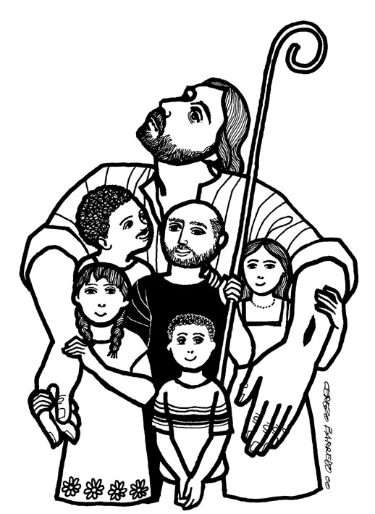

Coon Valley Lutheran Church
Fourth Sunday of Easter
Mother’s Day
May 8, 2022

~Bulletins are in memory of John & Maxine Rahanian from Cindy Swartz

Coffee Servers: Carl Holte & Monte Nelson
Altar Guild: 8:00/Cindy Swartz; 10:30/Kari Buros
Communion Servers: 8:00/Amanda Buros; 10:30/Ray Williamson
Head Ushers: 8a/; 10:30/
Readers: 8a/Mike Lusk; 10:30/Brian Rude
Attendance and offering last Sunday: 8am-85; 10:30-26 =111; $4,073.53
Sunday School Attendance last Sunday: 18

SCHEDULE
TODAY: 10:00a/Men’s Club meeting in Dining Room

MONDAY: 6:00p/Finance Committee; Pastor Julie’s Sabbath

TUESDAY: 9:00a-1:00p/South Conf. Pastors

WEDNEDAY: 9:00a/Quilting

THURSDAY: 6:00p/Church Council

NEXT SUNDAY: 9:00a/Worship

Coon Valley Lutheran Church
www.coonvalleylutheranchurch.org
Pastor: Rev. Julie Wollman, pastorjuliecvlc@gmail.com Home Phone 634-3797
Office Administrator: Jamie Thomas, jamiel@mwt.net
Office Hours: Wednesday 9:00a-2:30p; Thursday & Friday 9:00a-4:00p
Office 452-3772/Cell 317-0007
Treasurer: Becky Lusk, treasurer1005@mwt.net
Organist: Mary Schultz
Indoor Custodian: Tracy Stellner

FIRST READING: ACTS 9:36-43

Now in Joppa there was a disciple whose name was Tabitha, which in Greek is Dorcas. She was devoted to good works and acts of charity. At that time she became ill and died. When they had washed her, they laid her in a room upstairs. Since Lydda was near Joppa, the disciples, who heard that Peter was there, sent two men to him with the request, “Please come to us without delay.” So Peter got up and went with them; and when he arrived, they took him to the room upstairs. All the widows stood beside him, weeping and showing tunics and other clothing that Dorcas had made while she was with them. Peter put all of them outside, and then he knelt down and prayed. He turned to the body and said, “Tabitha, get up.” Then she opened her eyes, and seeing Peter, she sat up. He gave her his hand and helped her up. Then calling the saints and widows, he showed her to be alive. This became known throughout Joppa, and many believed in the Lord. Meanwhile he stayed in Joppa for some time with a certain Simon, a tanner.

The Word of the Lord. Thanks be to God.

PSALM 23 (read responsively)
The Lord is my shepherd, I shall not want.
He makes me lie down in green pastures; he leads me beside still waters;
he restores my soul. He leads me in right paths for his name’s sake.
Even though I walk through the darkest valley, I fear no evil; for you are with me; your rod and your staff— they comfort me.
You prepare a table before me in the presence of my enemies; you anoint my head with oil; my cup overflows.
Surely goodness and mercy shall follow me all the days of my life, and I shall dwell in the house of the Lord my whole life long.

SECOND READING: REVELATION 7:9-17
After this I looked, and there was a great multitude that no one could count, from every nation, from all tribes and peoples and languages, standing before the throne and before the Lamb, robed in white, with palm branches in their hands. They cried out in a loud voice, saying, “Salvation belongs to our God who is seated on the throne, and to the Lamb!” And all the angels stood around the throne and around the elders and the four living creatures, and they fell on their faces before the throne and worshiped God, singing, “Amen! Blessing and glory and wisdom and thanksgiving and honor and power and might be to our God forever and ever! Amen.” Then one of the elders addressed me, saying, “Who are these, robed in white, and where have they come from?” I said to him, “Sir, you are the one that knows.” Then he said to me, “These are they who have come out of the great ordeal; they have washed their robes and made them white in the blood of the Lamb. For this reason they are before the throne of God, and worship him day and night within his temple, and the one who is seated on the throne will shelter them. They will hunger no more, and thirst no more; the sun will not strike them, nor any scorching heat; for the Lamb at the center of the throne will be their shepherd, and he will guide them to springs of the water of life, and God will wipe away every tear from their eyes.”
The Word of the Lord. Thanks be to God.

GOSPEL READING: JOHN 10:22-30
At that time the festival of the Dedication took place in Jerusalem. It was winter, and Jesus was walking in the temple, in the portico of Solomon. So the Jews gathered around him and said to him, “How long will you keep us in suspense? If you are the Messiah, tell us plainly.” Jesus answered, “I have told you, and you do not believe. The works that I do in my Father’s name testify to me; but you do not believe, because you do not belong to my sheep. My sheep hear my voice. I know them, and they follow me. I give them eternal life, and they will never perish. No one will snatch them out of my hand. What my Father has given me is greater than all else, and no one can snatch it out of the Father’s hand. The Father and I are one.”
The Gospel of the Lord. Thanks be to God.

*We are always so happy to include you and our CVLC family in our prayers. If you feel your name, or the name of a family member can be removed from this list please contact Jamie. Thank you!

We remember in prayer:
† Those hospitalized this past week: Jim Knutson; Larry Lichtie
† Our members whose names we lift up in prayer today: Corrine Appleman, Beverly Bagstad, Eleanor Bagstad, Tip Bagstad, Clifford Bakkum, Inez Beck, Brian Berg, Darin Berg, Ellie Brye, Jeanne Ebli, Kira Foster, Lucy Hardie, Raymond Holen, Bonnie Holey, Verlin Ihle, Todd King, Jim Knutson, Paul Kogut, Margaret Lee, Russell Lee, Aaron Leisso, Gerri Leum, Larry Lichtie, Cindy Manske, Aaron Marx, Frank Mathison, Judy Mathison, Bud Miyamoto, Bob Moilien, Romaine Nelson, Corrine Nelson, Sandy Nelson, Cathy Ofte, Eunice Quast, Jojo Satona, Mary Schultz, Billie Slater, LaVonne Stendahl, Nancy Stuempges, Joyce Temp, Teri Tomten
† Our members who are currently in health care facilities: Rachel Berg, Evelyn Dahlen, Joanne Fletcher, Erma Graupe, Dennis Holen, Donna Ihle, Sylvester King Jr., Glen Marshall, Irene Nestingen, Tim Ofte, Beatrice Olson (Alden), Beatrice Olson (Leonard), Betty Sanders, Arlene Townsend.
† Those who grieve
† Our members who are currently home-bound
† All those in need of God’s healing and help
† Family and friends of our members
† All those affected by recent floods
† All those affected by the COVID-19 virus

