COON VALLEY LUTHERAN CHURCH
“We are a family of God, striving to enrich
the lives of all through the love of Christ”

PRELUDE MUSIC
Why Me Lord #15
Christ is Knocking #6
One Day at a Time #3

~ GATHERING ~
The Holy Spirit calls us together as the people of God

WELCOME and ANNOUNCMENTS

GATHERING SONG Chapel in the Valley #4

CALL to WORSHIP
We sing of God the Spirit,
who from the beginning has swept over the face of creation and moves in the human heart.
We sing of God the Spirit,
faithful and untamable, who is creatively and redemptively active in the world.
We sing of God the Spirit,
who speaks our prayers of deepest longing and hears our concerns and confessions.
We sing of God the Spirit,
who is transforming us and the world.
We offer worship
as an outpouring of gratitude and awe.
We open ourselves
to God’s still voice of comfort and to God’s rushing whirlwind of challenge.
By the power of the Spirit, God changes our lives, our relationships, and our world.
Thanks be to God!

GREETING and PRAYER of the DAY
The grace of our Lord Jesus Christ, the love of
God, and the communion of the Holy Spirit be with you all. And also with you.

Mighty God, you breathe life into our bones, and your Spirit brings truth to the world. Send us this Spirit, transform us by your truth, and give us language to proclaim your gospel, through Jesus Christ, our Savior and Lord, who lives and reigns with you and the Holy Spirit, one God, now and forever. Amen.

SONG of PRAISE How Great Thou Art #12

~ WORD ~
God speaks to us in scripture reading, preaching, and song

FIRST READING Acts 2:1-21

SECOND READING Romans 8:14-17

SCRIPTURE SONG Alleluia

GOSPEL John 14:8-17, 25-27
This is the Gospel of the Lord. Praise to you, O Christ.

SERMON Pastor Julie Wollman

SERMON SONG The Spirit is A Movin’

~ RESPONSE TO THE WORD ~
The Holy Spirit calls us as a community to reach out to each other
and offer gifts and prayers for God’s purposes

PRAYERS of INTERCESSION
Each petition ends…Hear us, O God. Your mercy is great.

OFFERING PRAYER
God of great wonders, we join with you in the joy of giving. You give us life and breath, you fill the world with beauty, our hands with bounty, and our hearts with the desire to give. Accept these gifts, and ourselves in your service. Amen.
OFFERING SONG Just a Closer Walk With Thee #1

~ MEAL ~
God feeds us with the presence of Jesus Christ

THE GREAT THANKSGIVING (spoken)
The Lord be with you. And also with you.
Lift up your hearts. We lift them to the Lord.
Let us give thanks to the Lord our God.
It is right to give him thanks and praise.

WORDS of INSTITUTION

THE LORD’S PRAYER #10

COMMUNION SONG In the Garden #24

POST-COMMUNION BLESSING

~ SENDING ~
God blesses us and sends us in mission to the world

BENEDICTION
The Lord bless you and keep you.
The Lord make his face to shine upon you and be gracious to you.
The Lord look upon you with favor and give you peace. Amen.

BELLS

SENDING SONGS God Bless America #14
Let the Son Shine In #11

DISMISSAL
Go in peace. Serve the Lord.
Thanks be to God!

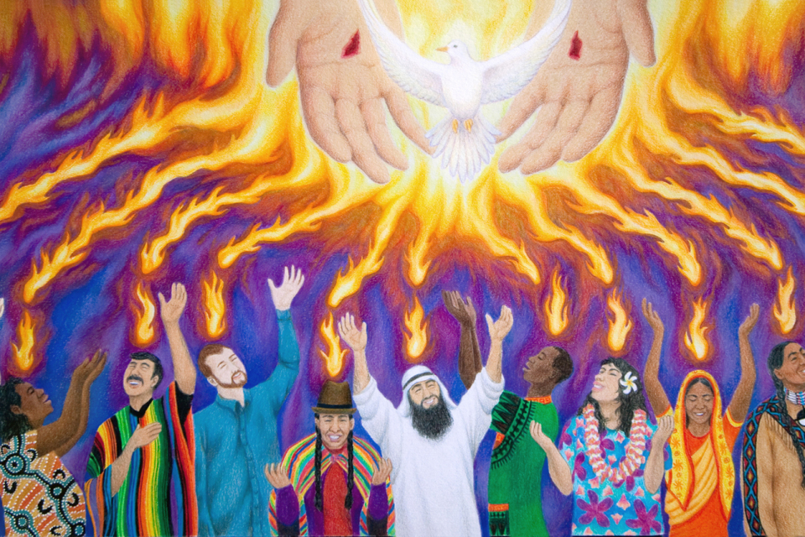

And they were filled with the Holy Spirit
Acts 2:4

COON VALLEY LUTHERAN CHURCH
June 5, 2022
Day of Pentecost
The Polka Mass-Ters

Head Usher:
Altar Guild:
Communion Server: Ron Moilien
Reader: Dan Wollman
Attendance and offering last Sunday: 10am-52; $2,038.89

SCHEDULE

MONDAY: Pastor Julie’s Sabbath

WEDNESDAY: 9:00a/Quilting

THURSDAY: 6:00p/Church Council

FRIDAY: Synod Assembly

SATURDAY: Synod Assembly

NEXT SUNDAY: 9:00a/Worship with Holy Communion 10:00a/Synod-Wide Worship @ Riverside Park La Crosse; Synod Assembly

Coon Valley Lutheran Church
www.coonvalleylutheranchurch.org
Pastor: Rev. Julie Wollman, pastorjuliecvlc@gmail.com Home Phone 634-3797
Office Administrator: Jamie Thomas, jamiel@mwt.net
Office Hours: Wednesday 9:00a-4:00p; Thursday 9:00a-4:00p
Office 452-3772/Cell 317-0007
Treasurer: Becky Lusk, treasurer1005@mwt.net
Organist: Mary Schultz
Indoor Custodian: Tracy Stellner

FIRST READING: ACTS 2:1-21
When the day of Pentecost had come, they were all together in one place. And suddenly from heaven there came a sound like the rush of a violent wind, and it filled the entire house where they were sitting. Divided tongues, as of fire, appeared among them, and a tongue rested on each of them. All of them were filled with the Holy Spirit and began to speak in other languages, as the Spirit gave them ability. Now there were devout Jews from every nation under heaven living in Jerusalem. And at this sound the crowd gathered and was bewildered, because each one heard them speaking in the native language of each. Amazed and astonished, they asked, “Are not all these who are speaking Galileans? And how is it that we hear, each of us, in our own native language? Parthians, Medes, Elamites, and residents of Mesopotamia, Judea and Cappadocia, Pontus and Asia, Phrygia and Pamphylia, Egypt and the parts of Libya belonging to Cyrene, and visitors from Rome, both Jews and proselytes, Cretans and Arabs—in our own languages we hear them speaking about God’s deeds of power.” All were amazed and perplexed, saying to one another, “What does this mean?” But others sneered and said, “They are filled with new wine.” But Peter, standing with the eleven, raised his voice and addressed them, “Men of Judea and all who live in Jerusalem, let this be known to you, and listen to what I say. Indeed, these are not drunk, as you suppose, for it is only nine o’clock in the morning. No, this is what was spoken through the prophet Joel: ‘In the last days it will be, God declares, that I will pour out my Spirit upon all flesh, and your sons and your daughters shall prophesy, and your young men shall see visions, and your old men shall dream dreams. Even upon my slaves, both men and women, in those days I will pour out my Spirit; and they shall prophesy. And I will show portents in the heaven above and signs on the earth below, blood, and fire, and smoky mist. The sun shall be turned to darkness and the moon to blood, before the coming of the Lord’s great and glorious day. Then everyone who calls on the name of the Lord shall be saved.’

The Word of the Lord. Thanks be to God.

SECOND READING: ROMANS 8:14-17
For all who are led by the Spirit of God are children of God. For you did not receive a spirit of slavery to fall back into fear, but you have received a spirit of adoption. When we cry, “Abba! Father!” it is that very Spirit bearing witness with our spirit that we are children of God, and if children, then heirs, heirs of God and joint heirs with Christ—if, in fact, we suffer with him so that we may also be glorified with him.
The Word of the Lord. Thanks be to God.

GOSPEL READING: JOHN 14:8-17, 25-27
Philip said to him, “Lord, show us the Father, and we will be satisfied.” Jesus said to him, “Have I been with you all this time, Philip, and you still do not know me? Whoever has seen me has seen the Father. How can you say, ‘Show us the Father’? Do you not believe that I am in the Father and the Father is in me? The words that I say to you I do not speak on my own; but the Father who dwells in me does his works. Believe me that I am in the Father and the Father is in me; but if you do not, then believe me because of the works themselves. Very truly, I tell you, the one who believes in me will also do the works that I do and, in fact, will do greater works than these, because I am going to the Father. I will do whatever you ask in my name, so that the Father may be glorified in the Son. If in my name you ask me for anything, I will do it. ”If you love me, you will keep my commandments. And I will ask the Father, and he will give you another Advocate, to be with you forever. This is the Spirit of truth, whom the world cannot receive, because it neither sees him nor knows him. You know him, because he abides with you, and he will be in you. ”I have said these things to you while I am still with you. But the Advocate, the Holy Spirit, whom the Father will send in my name, will teach you everything, and remind you of all that I have said to you. Peace I leave with you; my peace I give to you. I do not give to you as the world gives. Do not let your hearts be troubled, and do not let them be afraid.
This is the Gospel of the Lord. Praise to you, O Christ.

*We are always so happy to include you and our CVLC family in our prayers. If you feel your name, or the name of a family member can be removed from this list please contact Jamie. Thank you!

We remember in prayer:
† Those hospitalized this past week
† Our members whose names we lift up in prayer today: Corrine Appleman, Beverly Bagstad, Eleanor Bagstad, Tip Bagstad, Clifford Bakkum, Inez Beck, Brian Berg, Darin Berg, Ellie Brye, Jeanne Ebli, Kira Foster, Lucy Hardie, Bonnie Holey, Donna Ihle, Verlin Ihle, Todd King, Jim Knutson, Paul Kogut, Margaret Lee, Russell Lee, Aaron Leisso, Gerri Leum, Larry Lichtie, Cindy Manske, Aaron Marx, Frank Mathison, Judy Mathison, Bud Miyamoto, Bob Moilien, Romaine Nelson, Corrine Nelson, Sandy Nelson, Cathy Ofte, Eunice Quast, Jojo Satona, Mary Schultz, Billie Slater, LaVonne Stendahl, Joyce Temp, Teri Tomten
† Our members who are currently in health care facilities: Rachel Berg, Evelyn Dahlen, Joanne Fletcher, Erma Graupe, Dennis Holen, Sylvester King Jr., Glen Marshall, Irene Nestingen, Tim Ofte, Beatrice Olson (Alden), Beatrice Olson (Leonard), Betty Sanders, Nancy Stuempges, Arlene Townsend.
† Those who grieve: Family of Raymond Holen; Ingeborg Remley; Rebecca Anderson; Michael Schultz
† Our members who are currently home-bound
† All those in need of God’s healing and help
† Family and friends of our members
† All those affected by recent floods
† All those affected by the COVID-19 virus

