COON VALLEY LUTHERAN CHURCH
“We are a family of God, striving to enrich
the lives of all through the love of Christ.”

PRELUDE Mary Schultz

~ GATHERING ~
The Holy Spirit calls us together as the people of God.

WELCOME and ANNOUNCEMENTS

Confession and Forgiveness
Blessed be the holy Trinity, + one God,
whose steadfast love endures forever.
Amen.

Let us confess our sin in the presence of God and of one another.

Merciful God,
we confess that we have not followed your path
but have chosen our own way.
Instead of putting others before ourselves,
we long to take the best seats at the table.
When met by those in need,
we have too often passed by on the other side.
Set us again on the path of life.
Save us from ourselves
and free us to love our neighbors.
Amen.

Hear the good news!
God does not deal with us according to our sins
but delights in granting pardon and mercy.
In the name of + Jesus Christ, your sins are forgiven.
You are free to love as God loves.
Amen.

HYMN of PRAISE ELW #779 Amazing Grace, How Sweet the Sound

~ WORD ~ (Scripture insert)
God speaks to us in scripture reading, preaching, and song.
FIRST READING: Proverbs 25:6-7
PSALM: 112 (read responsively)
GOSPEL READING: Luke 14:1, 7-14
Word of God. Word of Life. Thanks be to God.

SERMON Pastor Meg Hoversten

HYMN of the DAY SOLO Mary Schultz
~ RESPONSE TO THE WORD ~
The Holy Spirit calls us as a community to say what we believe,
reach out to each other and offer gifts and prayers for God’s purposes.

THE APOSTLES’ CREED
I believe in God, the Father Almighty,
Creator of Heaven and earth;
I believe in Jesus Christ, God’s only Son Our Lord,
who was conceived by the Holy Spirit,
born of the Virgin Mary,
suffered under Pontius Pilate,
was crucified, died, and was buried;
he descended to the dead.
On the third day he rose again;
he ascended into heaven,
he is seated at the right hand of the Father,
and he will come to judge the living and the dead.
I believe in the Holy Spirit,
the holy catholic church,
the communion of saints,
the forgiveness of sins,
the resurrection of the body,
and the life everlasting. Amen.

PRAYERS of INTERCESSION
Petitions end: Merciful God, receive our prayer.

THE LORD’S PRAYER
Our Father who art in heaven, hallowed be thy name, thy kingdom come, thy will be done, on earth as it is in heaven.
Give us this day our daily bread; and forgive us our trespasses,
as we forgive those who trespass against us;
and lead us not into temptation, but deliver us from evil.
For thine is the kingdom, and the power, and the glory,
forever and ever. Amen.

OFFERING and OFFERTORY PRAYER
Blessed are you, O God, maker of all things. Through your goodness you have blessed us with these gifts: ourselves, our time, and our possessions. Use us, and what we have gathered, in feeding the world with your love, through the one who gave himself for us, Jesus Christ, our Savior and Lord. Amen.

~SENDING ~
God blesses us and sends us in mission to the world.

BENEDICTION

BELLS

SENDING HYMN ELW#774 What a Fellowship, What a Joy Divine

DISMISSAL Go in peace. Serve our risen Lord! Thanks be to God. Alleluia!

POSTLUDE Mary Schultz

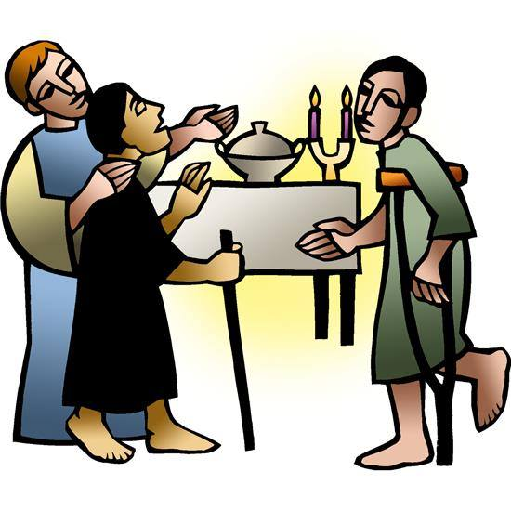
“A Bigger Table”
Luke 14:1, 7-14

Coon Valley Lutheran Church
The Twelfth Sunday after Pentecost
August 28, 2022

~Bulletins are in honor of the 50th wedding anniversary of Dave & Jan Verse

~We thank Pastor Meg Hoversten for leading worship today!

Head Usher: Janice Bender
Reader: Bruce King

SCHEDULE
MONDAY: 1:00-6:00p/Blood Drive
WEDNESDAY: 9:00a/Quilting

NEXT SUNDAY: 9:00a/Worship with Holy Communion; 10:00a/Pastor Julie worship at Middle Coon Valley

*Pastor Julie will be on vacation Aug. 21st after worship until Aug. 29th. She will be back in the office on Tuesday Aug. 30th. In this time, please contact Jamie at one of the numbers listed below for a pastoral emergency or any other need. Thank you!

Coon Valley Lutheran Church
www.coonvalleylutheranchurch.org
Pastor: Rev. Julie Wollman, pastorjuliecvlc@gmail.com Home Phone 634-3797
Office Administrator: Jamie Thomas, jamiel@mwt.net
Office Hours: Wednesday & Thursday 9:00a-4:00p
Office 452-3772/Cell 317-0007
Treasurer: Becky Lusk, treasurer1005@mwt.net
Organist: Mary Schultz
Indoor Custodian: Tracy Stellner

FIRST READING: PROVERBS 25:6-7
Do not put yourself forward in the king’s presence
or stand in the place of the great; for it is better to be told, “Come up here,” than to be put lower in the presence of a noble.
The Word of the Lord. Thanks be to God.

PSALM 112 (read responsively)
Praise the Lord! Happy are those who fear the Lord, who greatly delight in his commandments.
Their descendants will be mighty in the land; the generation of the upright will be blessed.
Wealth and riches are in their houses, and their righteousness endures forever.
They rise in the darkness as a light for the upright; they are gracious, merciful, and righteous.
It is well with those who deal generously and lend, who conduct their affairs with justice.
For the righteous will never be moved; they will be remembered forever.
They are not afraid of evil tidings; their hearts are firm, secure in the Lord.
Their hearts are steady, they will not be afraid; in the end they will look in triumph on their foes.
They have distributed freely, they have given to the poor; their righteousness endures forever; their horn is exalted in honor.
The wicked see it and are angry; they gnash their teeth and melt away; the desire of the wicked comes to nothing.

GOSPEL READING: LUKE 14:1, 7-14
On one occasion when Jesus was going to the house of a leader of the Pharisees to eat a meal on the sabbath, they were watching him closely.
When he noticed how the guests chose the places of honor, he told them a parable. “When you are invited by someone to a wedding banquet, do not sit down at the place of honor, in case someone more distinguished than you has been invited by your host; and the host who invited both of you may come and say to you, ‘Give this person your place,’ and then in disgrace you would start to take the lowest place. But when you are invited, go and sit down at the lowest place, so that when your host comes, he may say to you, ‘Friend, move up higher’; then you will be honored in the presence of all who sit at the table with you. For all who exalt themselves will be humbled, and those who humble themselves will be exalted.” He said also to the one who had invited him, “When you give a luncheon or a dinner, do not invite your friends or your brothers or your relatives or rich neighbors, in case they may invite you in return, and you would be repaid. But when you give a banquet, invite the poor, the crippled, the lame, and the blind. And you will be blessed, because they cannot repay you, for you will be repaid at the resurrection of the righteous.”
Word of God. Word of Life. Thanks be to God.

*We are always so happy to include you and our CVLC family in our prayers. If you feel your name, or the name of a family member can be removed from this list please contact Jamie. Thank you!

We remember in prayer:
† Those hospitalized this past week
† Our members whose names we lift up in prayer today: Corrine Appleman, Beverly Bagstad, Eleanor Bagstad, Tip Bagstad, Clifford Bakkum, Inez Beck, Brian Berg, Darin Berg, Jeanne Ebli, Kira Foster, Lucy Hardie, Lenore Henley, Bonnie Holey, Donna Ihle, Verlin Ihle, Todd King, Jim Knutson, Paul Kogut, Margaret Lee, Russell Lee, Aaron Leisso, Gerri Leum, Larry Lichtie, Cindy Manske, Aaron Marx, Frank Mathison, Judy Mathison, Bud Miyamoto, Romaine Nelson, Sandy Nelson, Cathy Ofte, Steve Pauloski, Eunice Quast, Jojo Satona, Mary Schultz, Billie Slater, LaVonne Stendahl, Joyce Temp, Teri Tomten
† Our members who are currently in health care facilities & Assisted Living:
Rachel Berg, Evelyn Dahlen, Joanne Fletcher, Erma Graupe, Gloria Graupe, Dennis Holen, Sylvester King Jr., Glen Marshall, Bob Moilien, Irene Nestingen, Tim Ofte, Beatrice Olson (Alden), Beatrice Olson (Leonard), Betty Sanders, Nancy Stuempges, Arlene Townsend.
† Those who grieve: Family and friends of Corrine Nelson
† Our members who are currently home-bound
† All those in need of God’s healing and help
† Family and friends of our members
† All those affected by the COVID-19 virus

