COON VALLEY LUTHERAN CHURCH
“We are a family of God, striving to enrich
the lives of all through the love of Christ.”
Sunday, September 11, 2022
8:00 a.m. and 10:30 a.m.

PRELUDE MUSIC
~ GATHERING ~
The Holy Spirit calls us together as the people of God

WELCOME and ANNOUNCEMENTS

CALL to WORSHIP

Loving God,
you call us to turn away from our own selfish interests,
to take up our cross, and to follow you.
To find our lives, may we live them in service of your mission.

As we come before you this morning,
give us open hearts and open hands.
Make us eager to hear your voice and seek your guidance.

Open our minds to your ever-present spirit
that is always moving within and around us.
Open our spirits to your nudging
and open our lives to your love.

CONFESSION and FORGIVENESS
Blessed be the holy Trinity, + one God,
who is eager to forgive
and who loves us beyond our days. Amen.

Dear friends, together let us acknowledge
our sin before God who creates in us anew hearts of love.

God of mercy and forgiveness,
we confess that sin still has a hold on us.
We have harmed your good creation.
We have failed to do justice,
love kindness,
and walk humbly with you.
Turn us in a new direction.
Show us the path that leads to life.
Be our refuge and strength on the journey,
through Jesus Christ, our redeemer and friend.
Amen.

Beloved of God:
your sins are forgiven + and you are made whole.
God points the way to new life in Christ,
who renews our spirit and restores to us the joy of God’s salvation! Amen.

HYMN of PRAISE ELW #807 Come Thou Fount of Every Blessing

10:30 a.m. INSTALLATION OF SUNDAY SCHOOL TEACHERS

~ WORD ~
God speaks to us in scripture reading, preaching, and song
FIRST READING: 1 Timothy 1:12-17
PSALM 51:1-12 (read responsively)
GOSPEL: Luke 15:1-10
The Word of the Lord. Thanks be to God.

SERMON

~ RESPONSE TO THE WORD ~
The Holy Spirit calls us as a community to say what we believe,
reach out to each other, and offer gifts and prayers for God’s purposes

PRAYERS of INTERCESSION
Petitions end: God of grace…hear our prayer.

OFFERING/OFFERTORY PRAYER
In the offering of our gifts, as well as the living of our days,
may we not grow weary of doing what is right, but commit to speaking up for the voiceless, healing the broken, feeding the hungry, and all those mercies which are such a part of your heart and hopes for all your children. In Jesus’ name, we pray. Amen.

~ SENDING ~
God blesses us and sends us in mission to the world
THE GREAT THANKSGIVING
The Lord be with you. And also with you.
Lift up your hearts. We lift them to the Lord.
Let us give thanks to the Lord our God.
It is right to give him thanks and praise.

THE WORDS of INSTITUTION

THE LORD’S PRAYER
Our Father who art in heaven, hallowed be thy name, thy kingdom come, thy will be done, on earth as it is in heaven.
Give us this day our daily bread; and forgive us our trespasses,
as we forgive those who trespass against us;
and lead us not into temptation, but deliver us from evil.
For thine is the kingdom, and the power, and the glory,
forever and ever. Amen.

COMMUNION SOLO Mary Schultz

POST-COMMUNION BLESSING

BENEDICTION

BELLS

SENDING HYMN ELW#676 Lord, Speak to Us That We May Speak

DISMISSAL Go in peace. Serve the Lord! Thanks be to God!

POSTLUDE Mary Schultz

0000000000000000000000000000000000

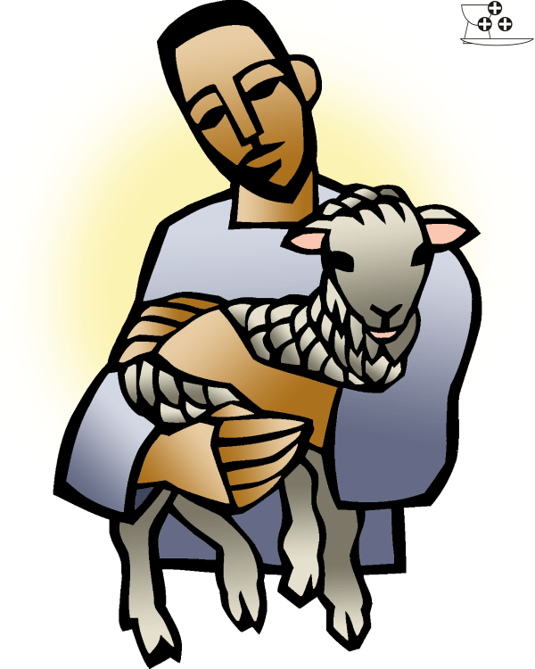
“Lost and Found”

COON VALLEY LUTHERAN CHURCH
September 11, 2022
Rally Sunday!
Fourteenth Sunday in the Season of Pentecost

~Thank you to Deanna Wichman for making the beautiful picture board of our Pet Blessing Service! Please view it in the entrance!

Coffee Servers: Marcie Nelson, Hazel Cornell
Head Usher: 8:00/Ken Phillips; 10:30/Jason Thomas
Reader: 8:00/Alex Hendrickson; 10:30/Mike Lieurance
Altar Guild: 8:00/ Cindy Swartz, Jane Simmons; 10:30/
Communion Server: 8:00/Mike Lusk; 10:30/Deb Holen

SCHEDULE
TODAY: 2:00p/Pastor Julie at Vernon Manor
MONDAY: Pastor Julie’s Sabbath
TUESDAY: 9:30a/South Conf. Pastors’
WEDNESDAY: 9:00a/Quilting; No Confirmation
THURSDAY: 10:00a/WELCA; Carillon Deadline

NEXT SUNDAY: 8:00 & 10:30a/Worship; 9:00a/Sunday School; Coffee Fellowship with Adolf Quast Presentation; Noon/Bridal Shower in Fellowship Hall

Coon Valley Lutheran Church
www.coonvalleylutheranchurch.org
Pastor: Rev. Julie Wollman, pastorjuliecvlc@gmail.com Home Phone 634-3797
Office Administrator: Jamie Thomas, jamiel@mwt.net
Office Hours: Tuesday, Wednesday, Thursday 9:00a-2:30p
Office 452-3772/Cell 317-0007
Treasurer: Becky Lusk, treasurer1005@mwt.net
Organist: Mary Schultz
Indoor Custodian: Tracy Stellner

FIRST READING: 1 TIMOTHY 1:12-17
I am grateful to Christ Jesus our Lord, who has strengthened me, because he judged me faithful and appointed me to his service, even though I was formerly a blasphemer, a persecutor, and a man of violence. But I received mercy because I had acted ignorantly in unbelief, and the grace of our Lord overflowed for me with the faith and love that are in Christ Jesus. The saying is sure and worthy of full acceptance, that Christ Jesus came into the world to save sinners—of whom I am the foremost. But for that very reason I received mercy, so that in me, as the foremost, Jesus Christ might display the utmost patience, making me an example to those who would come to believe in him for eternal life. To the King of the ages, immortal, invisible, the only God, be honor and glory forever and ever. Amen.
The Word of the Lord. Thanks be to God.

PSALM 51: 1-12 (read responsively)
Have mercy on me, O God, according to your steadfast love; according to your abundant mercy blot out my transgressions.
Wash me thoroughly from my iniquity, and cleanse me from my sin.
For I know my transgressions, and my sin is ever before me.
Against you, you alone, have I sinned, and done what is evil in your sight, so that you are justified in your sentence and blameless when you pass judgment.
Indeed, I was born guilty, a sinner when my mother conceived me.
You desire truth in the inward being; therefore teach me wisdom in my secret heart.
Purge me with hyssop, and I shall be clean; wash me, and I shall be whiter than snow.
Let me hear joy and gladness; let the bones that you have crushed rejoice.
Hide your face from my sins, and blot out all my iniquities.
Create in me a clean heart, O God, and put a new and right spirit within me.
Do not cast me away from your presence, and do not take your holy spirit from me.
Restore to me the joy of your salvation, and sustain in me a willing spirit.

GOSPEL READING: LUKE 15:1-10
Now all the tax collectors and sinners were coming near to listen to him. And the Pharisees and the scribes were grumbling and saying, “This fellow welcomes sinners and eats with them.” So he told them this parable: “Which one of you, having a hundred sheep and losing one of them, does not leave the ninety-nine in the wilderness and go after the one that is lost until he finds it? When he has found it, he lays it on his shoulders and rejoices. And when he comes home, he calls together his friends and neighbors, saying to them, ‘Rejoice with me, for I have found my sheep that was lost.’ Just so, I tell you, there will be more joy in heaven over one sinner who repents than over ninety-nine righteous persons who need no repentance. “Or what woman having ten silver coins, if she loses one of them, does not light a lamp, sweep the house, and search carefully until she finds it? When she has found it, she calls together her friends and neighbors, saying, ‘Rejoice with me, for I have found the coin that I had lost.’ Just so, I tell you, there is joy in the presence of the angels of God over one sinner who repents.”
The Word of the Lord. Thanks be to God.

*We are always so happy to include you and our CVLC family in our prayers. If you feel your name, or the name of a family member can be removed from this list please contact Jamie. Thank you!

We remember in prayer:
† Those hospitalized this past week
† Our members whose names we lift up in prayer today: Corrine Appleman, Beverly Bagstad, Eleanor Bagstad, Tip Bagstad, Clifford Bakkum, Inez Beck, Brian Berg, Darin Berg, Jeanne Ebli, Kira Foster, Lucy Hardie, Lenore Henley, Bonnie Holey, Donna Ihle, Verlin Ihle, Todd King, Jim Knutson, Paul Kogut, Margaret Lee, Russell Lee, Aaron Leisso, Gerri Leum, Larry Lichtie, Cindy Manske, Aaron Marx, Frank Mathison, Judy Mathison, Bud Miyamoto, Romaine Nelson, Sandy Nelson, Cathy Ofte, Steve Pauloski, Eunice Quast, Jojo Satona, Mary Schultz, Billie Slater, LaVonne Stendahl, Joyce Temp, Teri Tomten
† Our members who are currently in health care facilities & Assisted Living:
Rachel Berg, Evelyn Dahlen, Joanne Fletcher, Erma Graupe, Dennis Holen, Sylvester King Jr., Glen Marshall, Bob Moilien, Irene Nestingen, Tim Ofte, Beatrice Olson (Alden), Beatrice Olson (Leonard), Betty Sanders, Nancy Stuempges, Arlene Townsend.
† Those who grieve: Family and friends of Gloria Graupe; Family and friends of Corrine Nelson
† Our members who are currently home-bound
† All those in need of God’s healing and help
† Family and friends of our members
† All those affected by the COVID-19 virus

