COON VALLEY LUTHERAN CHURCH
“We are a family of God, striving to enrich
the lives of all through the love of Christ.”

~ GATHERING ~
The Holy Spirit calls us together as the people of God
WELCOME and ANNOUNCEMENTS

CALL TO WORSHIP I Am Bound for the Promised Land Deanna Wichman

Confession and Forgiveness
Blessed be the holy Trinity, + one God,
who redeems us in Christ Jesus,
whose steadfast love endures forever. Amen.

Let us confess our sin in the presence of God and of one another.

Silence is kept for reflection.

Most merciful God,
we confess that we have sinned against you
and our neighbors.
We have ignored voices
that call for your justice.
We have neglected actions
that witness to your righteousness.
We have spoken and acted
in ways that disrupt your beloved community.
We truly repent of things we have done
and left undone.
For the sake of Jesus Christ, have mercy on us.
Restore our troubled spirits,
so that we may live in newness,
follow the way of the Spirit,
and build up the body of Christ. Amen.

Rejoice and be glad!
God hears the prayers of all who cry out,
and restores us to life through the death
and resurrection of Jesus Christ.
Therefore, I declare to you the forgiveness of all your sins,
in the name of the Father, and of the + Son, and of the Holy Spirit. Amen.

GATHERING HYMN ELW#864 Praise My Soul, the God of Heaven

GREETING and KYRIE ELW page 147
The grace of our Lord Jesus Christ, the love of God, and the communion of the Holy Spirit be with you all. And also with you.

CANTICLE of PRAISE ELW page 149

PRAYER of the DAY
O God, the protector of all who trust in you, without you nothing is strong, nothing is holy. Embrace us with your mercy, that with you as our ruler and guide, we may live through what is temporary without losing what is eternal, through Jesus Christ, our Savior and Lord.

~ WORD ~
God speaks to us in scripture reading, preaching, and song
FIRST READING: 2 Thessalonians 3:6-13
PSALM 98 (read responsively)
GOSPEL ACCLAMATION ELW page 151
Alleluia. Lord, to whom shall we go?
You have the words of eternal life. Alleluia.
GOSPEL READING: Luke 21:5-19

SERMON

HYMN of the DAY SOLO O God, Our Help in Ages Past Mary Schultz

~ RESPONSE TO THE WORD ~
The Holy Spirit calls us as a community to say what we believe,
reach out to each other, and offer gifts and prayers for God’s purposes
8:00 a.m. RECEPTION OF NEW MEMBERS

PRAYERS of INTERCESSION
Lord, in your mercy…receive our prayer.

OFFERING/OFFERTORY PRAYER
Blessed are you, O God, maker of all things. Through your goodness you have blessed us with these gifts: ourselves, our time, and our possessions. Use us, and what we have gathered, in feeding the world with your love, through the one who gave himself for us, Jesus Christ, our Savior and Lord. Amen.

THE GREAT THANKSGIVING
The Lord be with you. And also with you.
Lift up your hearts. We lift them to the Lord.
Let us give thanks to the Lord our God.
It is right to give him thanks and praise.

WORDS OF INSTITUTION

THE LORD’S PRAYER
Our Father who art in heaven, hallowed be thy name, thy kingdom come, thy will be done, on earth as it is in heaven.
Give us this day our daily bread; and forgive us our trespasses,
as we forgive those who trespass against us;
and lead us not into temptation, but deliver us from evil.
For thine is the kingdom, and the power, and the glory,
forever and ever. Amen.

COMMUNION
SOLO Mary Schultz

POST COMMUNION BLESSING and PRAYER

~ SENDING ~
God blesses us and sends us in mission to the world
BLESSING
The God of peace, who creates all things and calls them good, who makes us alive in Jesus, and who breathes o us the Spirit of hope, bless you now and forever. Amen.

SENDING HYMN ELW #796 How Firm a Foundation

DISMISSAL Go in peace. You are a blessed to be a blessing. Thanks be to God!

POSTLUDE Mary Schultz
00000000000000000

-Leonard Cohen, Anthem

The Twenty-Third Sunday in the Season of Pentecost
New Member Welcome
November 13, 2022

~Bulletins are in celebration of the wedding of Emmitt Edwards & Maddie Gynild from Jan Bender family

Coffee Servers: Melinda Marsh, Allison Williamson
Acolyte: 8:00/Evan Williamson; 10:30/Makenna Gartner
Head Usher: 8:00/Steve Nelson; 10:30/Jason Thomas
Altar Guild: 8:00/Jane Simmons & Cindy Swartz; 10:30/Sarah Ofte
Communion Servers: 8:00/Glen Hoff; 10:30/Ray Williamson
Reader: 8:00/Jane Simmons; 10:30/Mark Hutson
Attendance & Offering Last Sunday: 8am/80; 10:30/30
Offering: $4,764.70
Sunday School Attendance Last Sunday: 17

SCHEDULE
TODAY: 9:00a/Coffee Fellowship, Sunday School
MONDAY: Pr. Julie’s Sabbath; Carillon Deadline
TUESDAY: 9:00a/Naomi Circle
WEDNESDAY: 4:00p/Confirmation
THURSDAY: 10:00a/WELCA
SUNDAY: 8 & 10:30a/Worship; 9:00a/Sunday School, Coffee Fellowship
Coon Valley Lutheran Church
www.coonvalleylutheranchurch.org
Pastor: Rev. Julie Wollman, pastorjuliecvlc@gmail.com Home Phone 634-3797
Office Administrator: Jamie Thomas, jamiel@mwt.net
Office Hours: Tuesday, Wednesday, Thursday 9:00a-2:30p
Office 452-3772/Cell 317-0007
Treasurer: Becky Lusk, treasurer1005@mwt.net
Organist: Mary Schultz
Indoor Custodian: Tracy Stellner

FIRST READING: 2 THESSALONIANS 3:6-13
Now we command you, beloved, in the name of our Lord Jesus Christ, to keep away from believers who are living in idleness and not according to the tradition that they received from us. For you yourselves know how you ought to imitate us: we were not idle when we were with you, and we did not eat anyone’s bread without paying for it; but with toil and labor we worked night and day, so that we might not burden any of you. This was not because we do not have that right, but in order to give you an example to imitate. For even when we were with you, we gave you this command: Anyone unwilling to work should not eat. For we hear that some of you are living in idleness, mere busybodies, not doing any work. Now such persons we command and exhort in the Lord Jesus Christ to do their work quietly and to earn their own living. Brothers and sisters, do not be weary in doing what is right.
The Word of the Lord. Thanks be to God.

PSALM 98 (read responsively)
O sing to the LORD a new song, for he has done marvelous things. His right hand and his holy arm have gotten him victory.
The LORD has made known his victory; he has revealed his vindication in the sight of the nations.
He has remembered his steadfast love and faithfulness t the house of Israel. All the ends of the earth have seen the victory of our God.
Make a joyful noise to the LORD, all the earth; break forth into joyous song and sing praises.
Sing praises to the LORD with the lyre, with the lyre and the sounds of melody.
With trumpets and the sound of the horn make a joyful noise before the King, the LORD.
Let the sea roar, and all that fills it; the world and those who live in it.
Let the floods clap their hands; let the hills sing together for joy at the presence of the LORD, for he is coming to judge the earth.
He will judge the world with righteousness, and the peoples with equity.

GOSPEL READING: LUKE 21:5-19
When some were speaking about the temple, how it was adorned with beautiful stones and gifts dedicated to God, Jesus said, “As for these things that you see, the days will come when not one stone will be left upon another; all will be thrown down.” They asked him, “Teacher, when will this be, and what will be the sign that this is about to take place?! And he said, “Beware that you are not led astray; for many will come in my name and say, ‘I am he!’ and, ‘The time is near!’ Do not go after them. “When you hear of wars and insurrections, do not be terrified; for these things must take pace first, but the end will not follow immediately.” Then he said to them, “Nation will rise against name, and kingdom against kingdom; there will be great earthquakes, and in various places famines and plagues; and there will be dreadful portents and great signs from heaven. “But before all this occurs, they will arrest you and persecute you; they will hand you over to synagogues and prisons, and you will be brought before kings and governors because of my name. This will give you an opportunity to testify. So make up your minds not to prepare your defense in advance; for I will give you words and a wisdom that none of your opponents will be able to withstand or contradict. You will be betrayed even by parents and brothers, by relatives and friends; and they will put some of you to death. You will be hated by all because of my name. But not a hair of your head will perish. By your endurance you will gain your souls.”
The Gospel of the Lord. Praise to you, O Christ.
*We are always so happy to include you and our CVLC family in our prayers. If you feel your name, or the name of a family member can be removed from this list please contact Jamie. Thank you!

We remember in prayer:
† Those hospitalized this past week: Sandy Nelson, Beatrice Olson (Leonard)
† Our members whose names we lift up in prayer today: Corrine Appleman, Beverly Bagstad, Eleanor Bagstad, Tip Bagstad, Clifford Bakkum, Inez Beck, Jeanne Ebli, Kira Foster, Sue Frydenlund, Lucy Hardie, Bonnie Holey, Donna Ihle, Verlin Ihle, Todd King, Jim Knutson, Paul Kogut, Margaret Lee, Russell Lee, Aaron Leisso, Gerri Leum, Larry Lichtie, Cindy Manske, Aaron Marx, Frank Mathison, Judy Mathison, Bud Miyamoto, Romaine Nelson, Sandy Nelson, Eunice Quast, Jojo Satona, Mary Schultz, Billie Slater, LaVonne Stendahl, Joyce Temp, Teri Tomten
† Our members who are currently in health care facilities & Assisted Living:
Rachel Berg, Evelyn Dahlen, Joanne Fletcher, Erma Graupe, Lenore Henley, Dennis Holen, Sylvester King Jr., Bob Moilien, Irene Nestingen, Cathy Ofte, Tim Ofte, Beatrice Olson (Alden), Beatrice Olson (Leonard), Betty Sanders, Nancy Stuempges, Arlene Townsend.
† Those who grieve: Family & Friends of Glen Marshall
† Our members who are currently home-bound
† All those in need of God’s healing and help
† Family and friends of our members
† All those affected by the COVID-19 virus

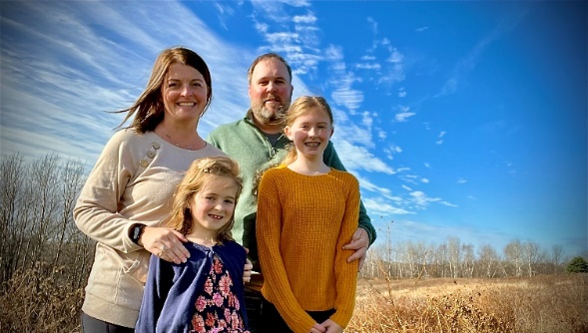
Meet our 2020 New Members!
Jaimie and Brian, Payton, & Avery Christianson
Brian works at 3RT Networks as a Network Engineer, Jaimie works at Trane as a Project Manager, Payton is 11 and is in 6th Grande at Longfellow Elementary in La Crosse, and Avery is 7 and is in 1st Grade at Southern Bluffs Elementary in La Crosse. In Brian’s free time he likes to Bass Fish, Jaimie crafts or spends time gardening, Payton plays Volleyball, Basketball, and Golf. Avery loves crafting, playing outside, and is starting to show interest in Volleyball.
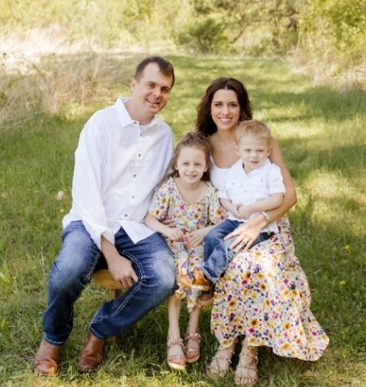
Collin and Natasha, Hattie & Ryker Olerud; Associate Members
Collin and Natasha live right outside of Chaseburg with their 2 children, Hattie (5) and Ryker (2) and a spunky little pup named Paris. Natasha and Collin are busy working multiple jobs and owning their most recent business - Codgers, located in Chaseburg. Hattie loves her babies, dolls and Barbie’s, while Ryker enjoys playing with his cars and shooting hoops. Collin and Natasha love to travel and in their downtime you will find them watching movies and enjoying the relaxing moments with their kiddos. We are so happy to be able to be part of such a wonderful church! Thank you!

Jason and Hannah, Henry & Hudson Raasch
Henry, Age 5
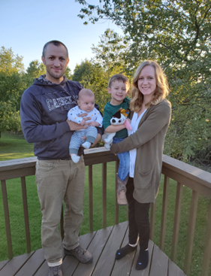
Hudson, Age 2
Not pictured:
Jeanne Ebli who was received into membership of our Congregation in 2020.

Meet our 2021 New Members!
Amy, Jamey, Lydia & Grady Evenstad
Our family resides near Coon Valley and we are lifelong residents of the area. Amy is employed at Vernon Memorial Healthcare as the Director of Human Resources and also an Occupational Therapist. Jamey is employed by Sleepy Hollow Ford as an automotive technician. Lydia graduated in 2021 from WHS and is in her second year at Viterbo in the nursing program. Grady is a freshman at WHS this year and a busy 3 sport athlete. We also have a family farm and raise beef. In our spare time you will find us enjoying time in the boat at the river, hiking, and enjoying the outdoors. Thank you for the warm welcome to CVLC!

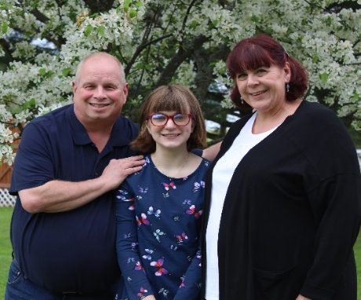
Jon, Stephanie & Addison Proksch
We live outside of Coon Valley on County road B
on a hobby farm. Addison is in 8th grade at
Westby Middle School.

Dr. Heather, Steve
& Deanna Wichman

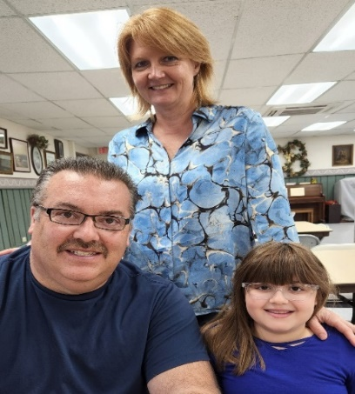

Meet our 2022 New Members!
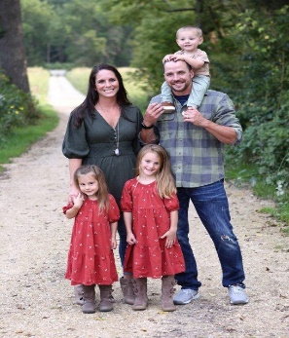
Daina & Dustin, Kinley, Jayda & Knox Drath
Daina, Dustin, Kinley (5), Jayda (4), and Knox (1)! (1). We have lived in Coon Valley now for 7 years and will probably be here for the next 70. :) It fits us perfectly and we feel so blessed to be here!

Jared & Alison, Elsie Emmart
The Emmart family is excited to join. We are a family of three, soon to become four in January. Jared works for United Health Group (formerly LHI) in La Crosse. Jared also serves as a Major in the Army Reserve. Alison has been teaching at Coon Valley Elementary School for eleven years. Elsie is busy loving life as a two-year-old. Elsie was also baptized in church, while wearing her great-great-grandmother's (Elsie Role) gown. We are excited to become a part of this church family.
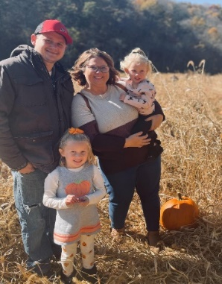
Matt & Holly, Eliza & Emelia Helgerson
Matt, Holly, Eliza and Emelia! You will find us enjoying family fun activities as we are always on the go making memories together! We are excited to join the church and for our children to start Sunday school.

Travis, Devin, Landon and Warren Lee

For just as the body is one and has many members, and all the members of the body, though many, are one body, so it is with Christ.
1 Corinthians 12:12

