COON VALLEY LUTHERAN CHURCH
“We are a family of God, striving to enrich
the lives of all through the love of Christ.”
Sunday, October 17, 2021
8:00 a.m. and 10:30 a.m.

PRELUDE Mary Schultz

~ GATHERING ~
The Holy Spirit calls us together as the people of God.

WELCOME and ANNOUNCEMENTS
CALL to WORSHIP
The word has come for us from God:
who promises to shelter us under the wings of hope and grace.
The word has come to us from Jesus:
who encourages us to remember the good news we have received.
The word flows to us from the Spirit:
who reminds us to place our hope and trust in God.

CONFESSION AND FORGIVENESS
Blessed be the Holy Trinity, One God, who looks upon us in compassion, forgives our sin, and heals our lives. Amen.

Let us confess our sins to the one who welcomes us with an open heart.
silence is kept for reflection.

Have Mercy, O God, against you, you alone, we have sinned. In your compassion, cleanse us from our sin and take away our guilt. Create in us a new heart and give us a steadfast spirit. Do not cast us away, but fill us with your Holy Spirit and restore your joy within us. Amen.

As tender as parent to child, so deep is God’s compassion for you. As high as heaven is above earth, so vast is God’s love for you. As far as east is from west, so far God removes your sin from you, renewing your life through Jesus Christ. Blessed be God who crowns us with mercy and love.
Blessed be God forever. Amen.

PRAYER of the DAY
Loving God, you turn your greatness into goodness for all the peoples of the earth. Shape us into willing servants of your kingdom, and make us desire always and only your will, through Jesus Christ, our Savior and Lord. Amen.

10:30 a.m. 3RD AND 4TH GRADE PRESENTATION OF BIBLES

PIANO SOLO I Want to Walk as a Child of the Light Mary Schultz

~ WORD ~ (Scripture insert)
God speaks to us in scripture reading, preaching, and song
FIRST READING: Isaiah 53:4-12
PSALM 91:9-16 (read responsively)
SECOND READING: Hebrews 5:1-10
GOSPEL: Mark 10:35-45
The Gospel of the Lord. Thanks be to God.

SERMON

HYMN of the DAY SOLO To Be Your Presence Mary Schultz

~ RESPONSE TO THE WORD ~
The Holy Spirit calls us as a community to say what we believe,
reach out to each other and offer gifts and prayers for God’s purposes.

PRAYERS of INTERCESSION
Hear us, O God….Your mercy is great.

THE LORD’S PRAYER
Our Father who art in heaven, hallowed be thy name, thy kingdom come, thy will be done, on earth as it is in heaven.
Give us this day our daily bread; and forgive us our trespasses,
as we forgive those who trespass against us;
and lead us not into temptation, but deliver us from evil.
For thine is the kingdom, and the power, and the glory,
forever and ever. Amen.

OFFERING and OFFERTORY PRAYER
Great God of Heaven and Earth,
you call us to leave behind our preoccupations
and to follow you into the future.
Sometimes we find your call challenging.
We are comfortable, maybe even complacent, in our present.
May this act of giving be a gesture of our willingness
to follow where you lead.
In Jesus’ name, we pray. Amen.

~SENDING ~
God blesses us and sends us in mission to the world.
BENEDICTION

BELLS

SENDING WORDS Go in peace. Serve the Lord. Thanks be to God!

SENDING HYMN ELW 712 Lord Whose Love in Humble Service

POSTLUDE Mary Schultz

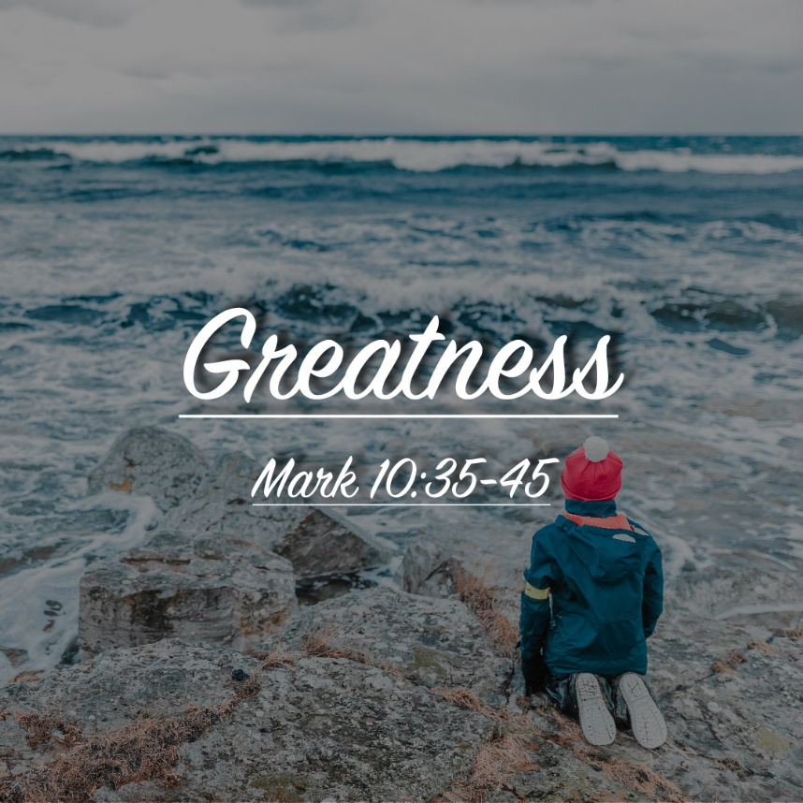

COON VALLEY LUTHERAN CHURCH
Twenty First Sunday after Pentecost
October 17, 2021

~Bulletins are in honor of Corky & Randy Amundson’s 40th Anniversary from Verlin & Jan Ihle

~Our 3rd & 4th graders who are eligible to receive Bibles today are: Jocelyn Buros, Hugh Hoff, Aaron Marx, Ella Peters, Mia Rudie; Abrielle Semke, Grace Strangstalien, Wyatt Strangstalien, Arthur Hoff, Alexis White, Riley Strangstalien, Adrianna Briggson, Kayla Coaty, Rayah Klum, Tyler Marsh, Jaxon Nelson, Jaxson Johsnon, Angel Stach, Emma Herman, Dylan Wiedemann

Coffee Servers: Gloria Galstad, Ainsley Lichtie
Head Ushers: Bob Moilien
Readers: 8/Nancy King; 10:30/Jane Simmons
Attendance & Offering October 10: 8a-44; 10:30-26=70; $2,289.05
Sunday School Attendance October 10: 15

Schedule

TODAY: 9:00/Sunday School; 11:00/Men’s Club Drive-Thru Meatball Dinner

MONDAY: Fall Theological Conference

TUESDAY: Fall Theological Conference

WEDNESDAY: Fall Theological Conference; 5:00p/NO CONFIMRATION

THURSDAY: 1:30/WELCA-Program “What You Need to Know About Scammers”

SATURDAY: Please remember to remove summer displays from the cemetery

NEXT SUNDAY: 8:00 & 10:30a/Worship; 9:00a/Sunday School

SUNDAY OCTOBER 31st THERE WILL BE ONE SERVICE AT 9:00AM
Coon Valley Lutheran Church
www.coonvalleylutheranchurch.org
Pastor: Rev. Julie Wollman, pastorjuliecvlc@gmail.com Home Phone 634-3797
Office Administrator: Jamie Thomas, jamiel@mwt.net
Office Hours: Tuesday 9:00a-2:30p; Wednesday & Thursday 9:00a-4:00p
Office 452-3772/Cell 317-0007
Treasurer: Becky Lusk, treasurer1005@mwt.net
Organist: Mary Schultz
Indoor Custodian: Tracy Stellner

FIRST READING: ISAIAH 53:4-12
Surely he has borne our infirmities and carried our diseases; yet we accounted him stricken, struck down by God, and afflicted. But he was wounded for our transgressions, crushed for our iniquities; upon him was the punishment that made us whole, and by his bruises we are healed. All we like sheep have gone astray; we have all turned to our own way, and the LORD has laid on him the iniquity of us all. He was oppressed, and he was afflicted, yet he did not open his mouth; like a lamb that is led to the slaughter, and like a sheep that before its shearers is silent, so he did not open his mouth. By a perversion of justice he was taken away. Who could have imagined his future? For he was cut off from the land of the living, stricken for the transgression of my people. They made his grave with the wicked and his tomb with the rich, although he had done no violence, and there was no deceit in his mouth. Yet it was the will of the LORD to crush him with pain. When you make his life an offering for sin, he shall see his offspring, and shall prolong his days; through him the will of the LORD shall prosper. Out of his anguish he shall see light; he shall find satisfaction through his knowledge. The righteous one, my servant, shall make many righteous, and he shall bear their iniquities. Therefore I will allot him a portion with the great, and he shall divide the spoil with the strong; because he poured out himself to death, and was numbered with the transgressors; yet he bore the sin of many, and made intercession for the transgressors.
The Word of the Lord. Thanks be to God.

PSALM 91:9-16 (read responsively)
Because you have made the LORD your refuge, the Most High your dwelling place, No evil shall befall you, no scourge come near your tent.
For he will command his angels concerning you to guard you in all your ways.
On their hands they will bear you up, so that you will not dash your foot against a stone.
You will tread on the lion and the adder, the young lion and the serpent you will trample under foot.
Those who love me, I will deliver; I will protect those who know my name.
When they call to me, I will answer them; I will be with them in trouble, I will rescue them and honor them.
With long life I will satisfy them, and show them my salvation.

SECOND READING: HEBREWS 5:1-10
Every high priest chosen from among mortals is put in charge of things pertaining to God on their behalf, to offer gifts and sacrifices for sins. He is able to deal gently with the ignorant and wayward, since he himself is subject to weakness; and because of this he must offer sacrifice for his own sins as well as for those of the people. And one does not presume to take this honor, but takes it only when called by God, just as Aaron was. So also Christ did not glorify himself in becoming a high priest, but was appointed by the one who said to him, “You are my Son, today I have begotten you”; as he says also in another place, “You are a priest forever, according to the order of Melchizedek.” In the days of his flesh, Jesus offered up prayers and supplications, with loud cries and tears, to the one who was able to save him from death, and he was heard because of his reverent submission. Although he was a Son, he learned obedience through what he suffered; and having been made perfect, he became the source of eternal salvation for all who obey him, having been designated by God a high priest according to the order of Melchizedek.
The Word of the Lord. Thanks be to God.

GOSPEL READING: MARK 10:35-45
James and John, the sons of Zebedee, came forward to Jesus and said to him, “Teacher, we want you to do for us whatever we ask of you.” And he said to them, “What is it you want me to do for you?” And they said to him, “Grant us to sit, one at your right hand and one at your left, in your glory.” But Jesus said to them, “You do not know what you are asking. Are you able to drink the cup that I drink, or be baptized with the baptism that I am baptized with?” They replied, “We are able.” Then Jesus said to them, “The cup that I drink you will drink; and with the baptism with which I am baptized, you will be baptized; but to sit at my right hand or at my left is not mine to grant, but it is for those for whom it has been prepared.” When the ten heard this, they began to be angry with James and John. So Jesus called them and said to them, “You know that among the Gentiles those whom they recognize as their rulers lord it over them, and their great ones are tyrants over them. But it is not so among you; but whoever wishes to become great among you must be your servant, and whoever wishes to be first among you must be slave of all. For the Son of Man came not to be served but to serve, and to give his life a ransom for many.”
The Gospel of the Lord. Thanks be to God.

*We are always so happy to include you and our CVLC family in our prayers. If you feel your name, or the name of a family member can be removed from this list please contact Jamie. Thank you!
We remember in prayer:
† Those hospitalized this past week
† Our members whose names we lift up in prayer today: Beverly Bagstad, Eleanor Bagstad, Tip Bagstad, Clifford Bakkum, Inez Beck, Kristin Boettcher, Ellie Brye, Chris Cabe, Jeanne Ebli, Kira Foster, Lucy Hardie, Bonnie Holey, Becky Ihle, Verlin Ihle, Jim Knutson, Paul Kogut, Margaret Lee, Russell Lee, Aaron Leisso, Gerri Leum, Larry Lichtie, Cindy Manske, Aaron Marx, Frank Mathison, Judy Mathison, Skyler Midtlien, Bud Miyamoto, Romaine Nelson, Sandy Nelson, Cathy Ofte, Lisa Olson, Pam Pauloski, Eunice Quast, Jojo Satona, Mary Schultz, Billie Slater, LaVonne Stendahl, Floyd Storey, Nancy Stuempges, Joyce Temp, Lanny Westphal, Renita Williamson
† Our members who are currently in health care facilities: Rachel Berg, Evelyn Dahlen, Joanne Fletcher, Erma Graupe, Sylvester King Jr., Irene Larson, Glen Marshall, Irene Nestingen, Tim Ofte, Beatrice Olson (Alden), Beatrice Olson (Leonard), Betty Sanders, Arlene Townsend.
† Those who grieve: Family and friends of Gilbert Leum; Frank Mathison and family in the death of Pauline Mathison and Leslie Mathison; Family and friends of Craig Engh & Shirley Engh; Family and friends of Margaret Lindahl
† Our members who are currently home-bound
† All those in need of God’s healing and help
† Family and friends of our members
† All those affected by recent floods
† All those affected by the COVID-19 virus

