COON VALLEY LUTHERAN CHURCH
“We are a family of God, striving to enrich
the lives of all through the love of Christ.”
June 26, 2022~9:00 a.m.

PRELUDE Mary Schultz

~ GATHERING ~
The Holy Spirit calls us together as the people of God.

WELCOME and ANNOUNCEMENTS

PRAYER of CONFESSION and FORGIVENESS
(Pray silently on your own and then we will speak this prayer together)

O God, who makes all things new,
new stars, new dust, new life;
take my heart,
every hardened edge and measured beat,
and create something new in me.

I need your newness, God,
the rough parts of me made smooth;
the stagnant, stirred;
the stuck, freed;
the unkind, forgiven.

And then, by the power of your Spirit,
I need to be turned toward Love again. Amen.

Our God is merciful and gracious, slow to anger, full of unfailing love.
Today, receive God’s forgiveness: By grace you have been saved.
In the name of Jesus Christ, your sins are forgiven. Almighty God strengthen you
with power through the Holy Spirit, that Christ may live in your hearts through faith. Thanks be to God!

ELW #798 Will You Come and Follow Me

GREETING and PRAYER of the DAY
The grace of our Lord Jesus Christ, the love of God, and the Communion of the Holy Spirit be with you all. And also with you.

Creating God, you call us to follow you and you favor us with true freedom. Keep us faithful to the ways of your Son, that, leaving behind all that hinders us, we may steadfastly follow your paths, through Jesus Christ, our Savior and Lord. Amen.

~ WORD ~ (Scripture insert)
God speaks to us in scripture reading, preaching, and song.

FIRST READING: Galatians 5:1, 13-25
PSALM: 16(read responsively)
Gospel: Luke 9:51-62
Word of God. Word of Life. Thanks be to God.

SERMON

HYMN of the DAY SOLO O Holy Spirit, Enter In Mary Schultz
~ RESPONSE TO THE WORD ~
The Holy Spirit calls us as a community to say what we believe,
reach out to each other and offer gifts and prayers for God’s purposes.

THE APOSTLES’ CREED
I believe in God, the Father Almighty,
Creator of Heaven and earth;
I believe in Jesus Christ, God’s only Son Our Lord,
who was conceived by the Holy Spirit,
born of the Virgin Mary,
suffered under Pontius Pilate,
was crucified, died, and was buried;
he descended to the dead.
On the third day he rose again;
he ascended into heaven,
he is seated at the right hand of the Father,
and he will come to judge the living and the dead.
I believe in the Holy Spirit,
the holy catholic church,
the communion of saints,
the forgiveness of sins,
the resurrection of the body,
and the life everlasting. Amen.

PRAYERS of INTERCESSION
Petitions end: God of grace, hear our prayer.

THE LORD’S PRAYER
Our Father who art in heaven, hallowed be thy name, thy kingdom come, thy will be done, on earth as it is in heaven.
Give us this day our daily bread; and forgive us our trespasses,
as we forgive those who trespass against us;
and lead us not into temptation, but deliver us from evil.
For thine is the kingdom, and the power, and the glory,
forever and ever. Amen.

OFFERING and OFFERTORY PRAYER
Blessed are you, O God, maker of all things. Through your goodness you have blessed us with these gifts: ourselves, our time, and our possessions. Use us, and what we have gathered, in feeding the world with your love, through the one who gave himself for us, Jesus Christ, our Savior and Lord. Amen.

~SENDING ~
God blesses us and sends us in mission to the world.
BENEDICTION

BELLS

SENDING HYMN ELW#767 Lord, Take My Hand and Lead Me

DISMISSAL Go in peace. Serve our risen Lord. Thanks be to God. Alleluia!

POSTLUDE Mary Schultz

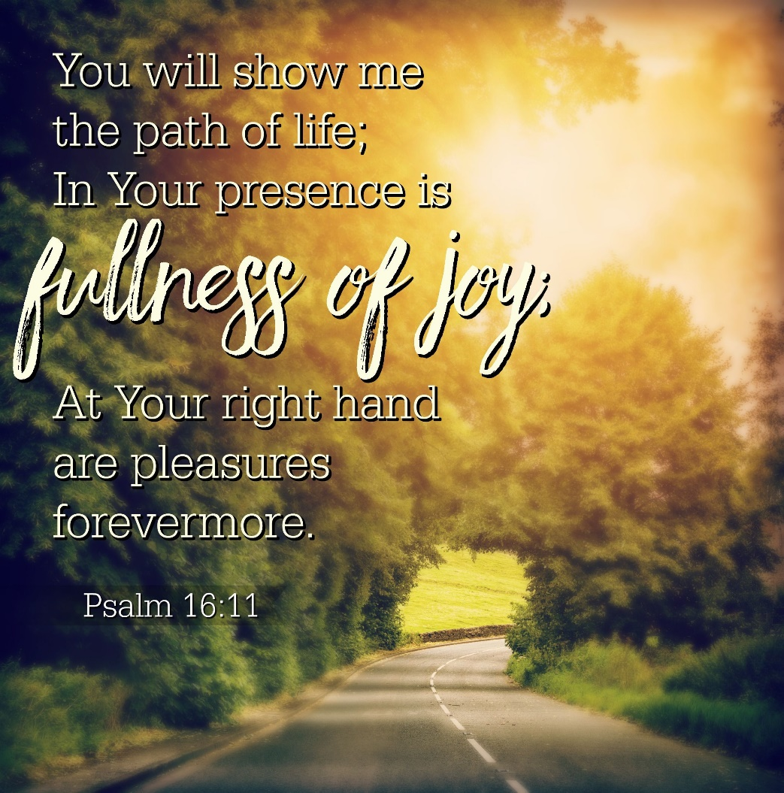

Coon Valley Lutheran Church
The Third Sunday after Pentecost
June 26, 2022

~Bulletins are in memory of Gary Betz, Pat Betz & Joan Betz from Jan Bender family

Head Usher: Steve Nelson
Reader: Josie Hofslien
Attendance and offering last Sunday: 9am-40; $2,044.36

SCHEDULE

MONDAY: Pastor Julie’s Sabbath

TUESDAY: 9:00a/Naomi Circle

WEDNESDAY: 9:00a/Quilting

NEXT SUNDAY: 9:00a/Worship with Holy Communion

Coon Valley Lutheran Church
www.coonvalleylutheranchurch.org
Pastor: Rev. Julie Wollman, pastorjuliecvlc@gmail.com Home Phone 634-3797
Office Administrator: Jamie Thomas, jamiel@mwt.net
Office Hours: Wednesday & Thursday 9:00a-4:00p
Office 452-3772/Cell 317-0007
Treasurer: Becky Lusk, treasurer1005@mwt.net
Organist: Mary Schultz
Indoor Custodian: Tracy Stellner

FIRST READING: GALATIANS 5:1, 13-25
For freedom Christ has set us free. Stand firm, therefore, and do not submit again to a yoke of slavery. For you were called to freedom, brothers and sisters; only do not use your freedom as an opportunity for self-indulgence, but through love become slaves to one another. For the whole law is summed up in a single commandment, “You shall love your neighbor as yourself.” If, however, you bite and devour one another, take care that you are not consumed by one another. Live by the Spirit, I say, and do not gratify the desires of the flesh. For what the flesh desires is opposed to the Spirit, and what the Spirit desires is opposed to the flesh; for these are opposed to each other, to prevent you from doing what you want. But if you are led by the Spirit, you are not subject to the law. Now the works of the flesh are obvious: fornication, impurity, licentiousness, idolatry, sorcery, enmities, strife, jealousy, anger, quarrels, dissensions, factions, envy, drunkenness, carousing, and things like these. I am warning you, as I warned you before: those who do such things will not inherit the kingdom of God. By contrast, the fruit of the Spirit is love, joy, peace, patience, kindness, generosity, faithfulness, gentleness, and self-control. There is no law against such things. And those who belong to Christ Jesus have crucified the flesh with its passions and desires. If we live by the Spirit, let us also be guided by the Spirit.
The Word of the Lord. Thanks be to God.

PSALM 16 (Read responsively)
Protect me, O God, for in you I take refuge.
I say to the Lord, “You are my Lord; I have no good apart from you.”
As for the holy ones in the land, they are the noble, in whom is all my delight.
Those who choose another god multiply their sorrows; their drink offerings of blood I will not pour out or take their names upon my lips.
The Lord is my chosen portion and my cup; you hold my lot.
The boundary lines have fallen for me in pleasant places; I have a goodly heritage.
I bless the Lord who gives me counsel; in the night also my heart instructs me.
I keep the Lord always before me; because he is at my right hand, I shall not be moved.
Therefore my heart is glad, and my soul rejoices; my body also rests secure.
For you do not give me up to Sheol, or let your faithful one see the Pit.
You show me the path of life. In your presence there is fullness of joy; in your right hand are pleasures forevermore.

GOSPEL READING: LUKE 9:51-62
When the days drew near for him to be taken up, he set his face to go to Jerusalem. And he sent messengers ahead of him. On their way they entered a village of the Samaritans to make ready for him; but they did not receive him, because his face was set toward Jerusalem. When his disciples James and John saw it, they said, “Lord, do you want us to command fire to come down from heaven and consume them?” But he turned and rebuked them. Then they went on to another village.
As they were going along the road, someone said to him, “I will follow you wherever you go.” And Jesus said to him, “Foxes have holes, and birds of the air have nests; but the Son of Man has nowhere to lay his head.” To another he said, “Follow me.” But he said, “Lord, first let me go and bury my father.” But Jesus said to him, “Let the dead bury their own dead; but as for you, go and proclaim the kingdom of God.” Another said, “I will follow you, Lord; but let me first say farewell to those at my home.” Jesus said to him, “No one who puts a hand to the plow and looks back is fit for the kingdom of God.”
Word of God. Word of Life. Thanks be to God.

*We are always so happy to include you and our CVLC family in our prayers. If you feel your name, or the name of a family member can be removed from this list please contact Jamie. Thank you!

We remember in prayer:
† Those hospitalized this past week: Larry Litchie
† Our members whose names we lift up in prayer today: Corrine Appleman, Beverly Bagstad, Eleanor Bagstad, Tip Bagstad, Clifford Bakkum, Inez Beck, Brian Berg, Darin Berg, Ellie Brye, Jeanne Ebli, Kira Foster, Lucy Hardie, Bonnie Holey, Donna Ihle, Verlin Ihle, Todd King, Jim Knutson, Paul Kogut, Margaret Lee, Russell Lee, Aaron Leisso, Gerri Leum, Larry Lichtie, Cindy Manske, Aaron Marx, Frank Mathison, Judy Mathison, Bud Miyamoto, Bob Moilien, Romaine Nelson, Corrine Nelson, Sandy Nelson, Cathy Ofte, Eunice Quast, Jojo Satona, Mary Schultz, Billie Slater, LaVonne Stendahl, Joyce Temp, Teri Tomten
† Our members who are currently in health care facilities: Rachel Berg, Evelyn Dahlen, Joanne Fletcher, Betty Gilbertson, Erma Graupe, Gloria Graupe, Dennis Holen, Sylvester King Jr., Glen Marshall, Irene Nestingen, Tim Ofte, Beatrice Olson (Alden), Beatrice Olson (Leonard), Betty Sanders, Nancy Stuempges, Arlene Townsend.
† Those who grieve
† Our members who are currently home-bound
† All those in need of God’s healing and help
† Family and friends of our members
† All those affected by recent floods
† All those affected by the COVID-19 virus

