COON VALLEY LUTHERAN CHURCH
“We are a family of God, striving to enrich
the lives of all through the love of Christ.”

PRELUDE MUSIC Mary Schultz
~ GATHERING ~
The Holy Spirit calls us together as the people of God

WELCOME and ANNOUNCEMENTS

CALL to WORSHIP
We come to this place—
each of us on our own path.
The path is winding,
and the path is not always clear,
and the path changes,
but we are here.
God is walking us home.
What a gift it is
to not walk alone.
Let us worship Holy God. Amen.

PRAYER of CONFESSION
God of changed plans,
The Magi heard in a dream that they were to take a new way home—
a different path, an untraveled road. And to our amazement, they did
just that.
The Magi packed their bags and went home by another way.
We wish that change could be easy for us, but more often than not,
when whispers of change come, we tend to clench our fists
and hold on tighter.
Forgive us for resisting change that might be holy.
Forgive us for ignoring that there is more than one road home.
Forgive us for failing to hear your invitation.
Guide our steps to unfamiliar places.
Gratefully we pray, amen.

PROCLAMATION of FORGIVENESS
No matter which roads we take in this one wild and precious life,
God walks with us. God never leaves our side. When the road changes and we find
ourselves on a new path home, God is always there.
So hear and believe this good news:
No matter where we go, no matter what we do, we are claimed, loved, and held by God. Thanks be to God for such love. Amen.

~ WORD ~
God speaks to us in scripture reading, preaching, and song

FIRST READING: Isaiah 60:1-6
Psalm 72:1-7, 10-14 (Read Responsively)
Ephesians 3:1-12
GOSPEL: Matthew 2:1-12
The Word of the Lord. Thanks be to God.

SERMON

HYMN of the DAY SOLO We Three Kings Mary Schultz

~ RESPONSE TO THE WORD ~
The Holy Spirit calls us as a community to say what we believe,
reach out to each other, and offer gifts and prayers for God’s purposes

PRAYERS of INTERCESSION
Lord, in your mercy…hear our prayer.

OFFERING/OFFERTORY PRAYER
Holy God, You are our home.
You and your goodness are the place we return to, the place we long to lay our head. So today as we offer you these gifts, we pray that you would take this offering and turn it into ministry. Use these gifts to transform the world we live in to better reflect the home you have envisioned for us—a home of peace, a home built on the foundation of love. Gratefully we pray, amen.

THE GREAT THANKSGIVING
The Lord be with you. And also with you.
Lift up your hearts. We lift them to the Lord.
Let us give thanks to the Lord our God.
It is right to give him thanks and praise.

WORDS OF INSTITUTION

THE LORD’S PRAYER
Our Father who art in heaven, hallowed be thy name, thy kingdom come, thy will be done, on earth as it is in heaven.
Give us this day our daily bread; and forgive us our trespasses,
as we forgive those who trespass against us;
and lead us not into temptation, but deliver us from evil.
For thine is the kingdom, and the power, and the glory,
forever and ever. Amen.

COMMUNION

SOLO What Child Is this? Mary Schultz

POST COMMUNION BLESSING and PRAYER

~ SENDING ~
God blesses us and sends us in mission to the world
BLESSING

BELLS

DISMISSAL

SENDING HYMN ELW #283 O Come All Ye Faithful

POSTLUDE Mary Schultz
00000000000000000

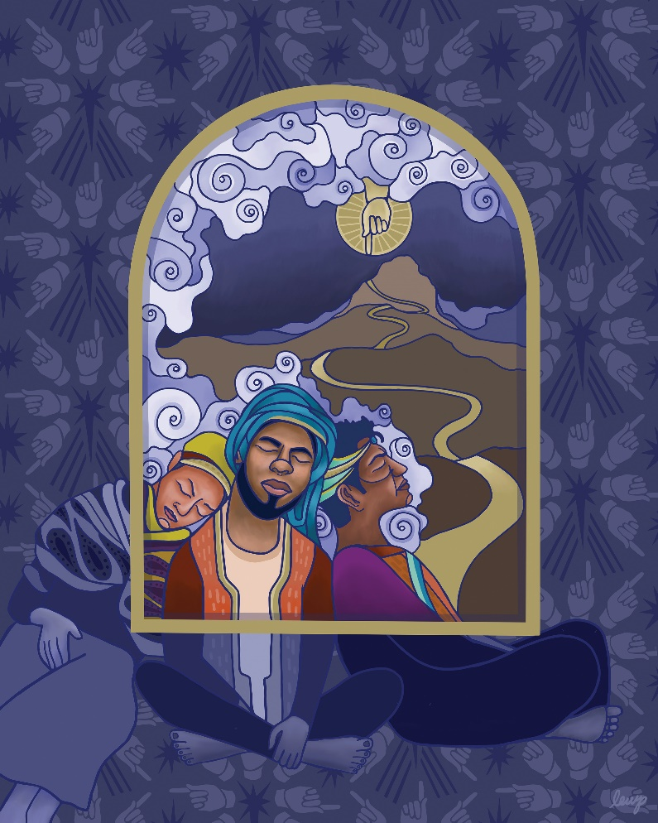
“The Wise Men’s Dream”
by Rev. Lauren Wright Pittman Inspired by Matthew 2:1-12

COON VALLEY LUTHERAN CHURCH
Sunday, January 2, 2022
Epiphany

Head Usher:
Reader:
Altar Guild:
Communion Server: Ray Williamson

MONDAY: Pastor Julie’s Sabbath; 1:00-6:00pm/Blood Drive

TUESDAY: 9:30a/Last Day to receive offerings for 2021

WEDNESDAY: 5:00p/Confirmation

practice

NEXT SUNDAY: 9:00a/Worship with Holy Communion

Offering envelopes are available. They are located on a table in the Dining Room. Please pick them up for family, friends or neighbors!

Coon Valley Lutheran Church
www.coonvalleylutheranchurch.org
Pastor: Rev. Julie Wollman, pastorjuliecvlc@gmail.com Home Phone 634-3797
Office Administrator: Jamie Thomas, jamiel@mwt.net
Office Hours: Tuesday 9:00a-2:30p; Wednesday & Thursday 9:00a-4:00p
Office 452-3772/Cell 317-0007
Treasurer: Becky Lusk, treasurer1005@mwt.net
Organist: Mary Schultz
Indoor Custodian: Tracy Stellner

FIRST READING: ISAIAH 60:1-6
Arise, shine; for your light has come, and the glory of the LORD has risen upon you. For darkness shall cover the earth, and thick darkness the peoples; but the LORD will arise upon you, and his glory will appear over you. Nations shall come to your light, and kings to the brightness of your dawn. Lift up your eyes and look around; they all gather together, they come to you; your sons shall come from far away, and your daughters shall be carried on their nurses’ arms. Then you shall see and be radiant; your heart shall thrill and rejoice, because the abundance of the sea shall be brought to you, the wealth of the nations shall come to you. A multitude of camels shall cover you, the young camels of Midian and Ephah; all those from Sheba shall come. They shall bring gold and frankincense, and shall proclaim the praise of the LORD.
The Word of the Lord. Thanks be to God

PSALM 72:1-7, 10-14
Give the king your justice, O God, and your righteousness to a king’s son.
May he judge your people with righteousness, and your poor with justice.
May the mountains yield prosperity for the people, and the hills, in righteousness.
May he defend the cause of the poor of the people, give deliverance to the needy, and crush the oppressor.
May he live while the sun endures, and as long as the moon, throughout all generations.
May he be like rain that falls on the mown grass, like showers that water the earth.
In his days may righteousness flourish and peace abound, until the moon is no more.
May the kings of Tarshish and of the isles render him tribute,
may the kings of Sheba and Seba bring gifts.
May all kings fall down before him, all nations give him service.
For he delivers the needy when they call, the poor and those who have no helper.
He has pity on the weak and the needy, and saves the lives of the needy.
From oppression and violence he redeems their life; and precious is their blood in his sight.

SECOND READING: EPHESIANS 3:1-12
This is the reason that I Paul am a prisoner for Christ Jesus for the sake of you Gentiles— for surely you have already heard of the commission of God’s grace that was given me for you, and how the mystery was made known to me by revelation, as I wrote above in a few words, a reading of which will enable you to perceive my understanding of the mystery of Christ. In former generations this mystery was not made known to humankind, as it has now been revealed to his holy apostles and prophets by the Spirit: that is, the Gentiles have become fellow heirs, members of the same body, and sharers in the promise in Christ Jesus through the gospel. Of this gospel I have become a servant according to the gift of God’s grace that was given me by the working of his power. Although I am the very least of all the saints, this grace was given to me to bring to the Gentiles the news of the boundless riches of Christ, and to make everyone see what is the plan of the mystery hidden for ages in God who created all things; so that through the church the wisdom of God in its rich variety might now be made known to the rulers and authorities in the heavenly places. This was in accordance with the eternal purpose that he has carried out in Christ Jesus our Lord, in whom we have access to God in boldness and confidence through faith in him.
The Word of the Lord. Thanks be to God.

GOSPEL READING: MATTHEW 2:1-12
In the time of King Herod, after Jesus was born in Bethlehem of Judea, wise men from the East came to Jerusalem, asking, “Where is the child who has been born king of the Jews? For we observed his star at its rising, and have come to pay him homage.” When King Herod heard this, he was frightened, and all Jerusalem with him; and calling together all the chief priests and scribes of the people, he inquired of them where the Messiah was to be born. They told him, “In Bethlehem of Judea; for so it has been written by the prophet: ‘And you, Bethlehem, in the land of Judah, are by no means least among the rulers of Judah; for from you shall come a ruler who is to shepherd my people Israel.’” Then Herod secretly called for the wise men and learned from them the exact time when the star had appeared. Then he sent them to Bethlehem, saying, “Go and search diligently for the child; and when you have found him, bring me word so that I may also go and pay him homage.” When they had heard the king, they set out; and there, ahead of them, went the star that they had seen at its rising, until it stopped over the place where the child was. When they saw that the star had stopped, they were overwhelmed with joy. On entering the house, they saw the child with Mary his mother; and they knelt down and paid him homage. Then, opening their treasure chests, they offered him gifts of gold, frankincense, and myrrh. And having been warned in a dream not to return to Herod, they left for their own country by another road.
The Word of the Lord. Thanks be to God.

*We are always so happy to include you and our CVLC family in our prayers. If you feel your name, or the name of a family member can be removed from this list please contact Jamie. Thank you!

We remember in prayer:
† Those hospitalized this past week
† Our members whose names we lift up in prayer today: Randy Amundson, Beverly Bagstad, Eleanor Bagstad, Tip Bagstad, Clifford Bakkum, Inez Beck, Kristin Boettcher, Ellie Brye, Chris Cabe, Kim Cade, Jeanne Ebli, Kira Foster, Lucy Hardie, Bonnie Holey, Becky Ihle, Verlin Ihle, Jim Knutson, Paul Kogut, Margaret Lee, Russell Lee, Aaron Leisso, Gerri Leum, Larry Lichtie, Cindy Manske, Aaron Marx, Frank Mathison, Judy Mathison, Skyler Midtlien, Bud Miyamoto, Romaine Nelson, Corrine Nelson, Sandy Nelson, Cathy Ofte, Lisa Olson, Pam Pauloski, Eunice Quast, Jojo Satona, Mary Schultz, Billie Slater, LaVonne Stendahl, Floyd Storey, Nancy Stuempges, Joyce Temp, Lanny Westphal, Renita Williamson
† Our members who are currently in health care facilities: Rachel Berg, Evelyn Dahlen, Joanne Fletcher, Erma Graupe, Sylvester King Jr., Irene Larson, Glen Marshall, Irene Nestingen, Tim Ofte, Beatrice Olson (Alden), Beatrice Olson (Leonard), Betty Sanders, Alice Marie Sather, Arlene Townsend.
† Those who grieve: Bill & Nancy Rogers in the death of their daughter Laura, Family of Roger Olson; Family of Ray Sedevie; Family of Burton Lee; Family of Valarie Holey;
Family of Tiffany Rundhaugen
† Our members who are currently home-bound
† All those in need of God’s healing and help
† Family and friends of our members
† All those affected by recent floods
† All those affected by the COVID-19 virus

