COON VALLEY LUTHERAN CHURCH
“We are a family of God, striving to enrich
the lives of all through the love of Christ.”

PRELUDE MUSIC Mary Schultz
~ GATHERING ~
The Holy Spirit calls us together as the people of God

WELCOME and ANNOUNCEMENTS

CONFESSION and FORGIVENESS
Blessed be the holy Trinity, + one God,
who makes all things new,
whose mercy endures forever. Amen.

Trusting in God's mercy, let us confess our sin.

Silence is kept for reflection.

Holy One, source of our renewal,
we confess that we are wrapped up in sin,
and cannot free ourselves.
We have not practiced your righteousness.
Our hearts have turned away from you.
For the sake of the world you so love,
forgive us,
that we may be reconciled to one another
for the glory of your holy name. Amen.

Thus says our God:
"The former things have come to pass
and new things I now declare."
God's mercy makes us new.
We are forgiven in the name of + Christ our Savior.
Amen.

GATHERING HYMN #870 We Praise You, O God

GREETING and KYRIE ELW pages 147 and 148
The grace of our Lord Jesus Christ, the love of God, and the communion of the Holy Spirit be with you all. And also with you.

CANTICLE of PRAISE ELW page 149

WORD ~
God speaks to us in scripture reading, preaching, and song

10:30 a.m. Order of Holy Baptism of Clayton Devere Hansen page 227

FIRST READING: Isaiah 42:1-9
Psalm 29 (Read responsively)
SECOND READING: Acts 10:34-43
GOSPEL: Matthew 3:13-17
Response after the Gospel reading: Praise to you, O Christ.

SERMON

HYMN of the DAY #445 Wash, O God Your Sons and Daughters

~ RESPONSE TO THE WORD ~
The Holy Spirit calls us as a community to say what we believe,
reach out to each other, and offer gifts and prayers for God’s purposes

PRAYERS of INTERCESSION
Petitions end: Lord, in your mercy…hear our prayer.

OFFERING and SOLO Baptized in Water Mary Schultz

OFFERING PRAYER
On my own what I have to give does not seem like much in the light of all you have given to me and in the face of so much need. Put together as a congregation, what we offer you here in love becomes more, not simply added together, but multiplied in its usefulness. We ask you to bless our gifts and with the addition of your blessing, just as it was with the loaves and fishes, may there be enough for all. Amen.

THE GREAT THANKSGIVING
The Lord be with you. And also with you.
Lift up your hearts. We lift them to the Lord.
Let us give thanks to the Lord our God.
It is right to give him thanks and praise.

WORDS OF INSTITUTION

THE LORD’S PRAYER
Our Father who art in heaven, hallowed be thy name, thy kingdom come, thy will be done, on earth as it is in heaven.
Give us this day our daily bread; and forgive us our trespasses,
as we forgive those who trespass against us;
and lead us not into temptation, but deliver us from evil.
For thine is the kingdom, and the power, and the glory,
forever and ever. Amen.

COMMUNION
SOLO Mary Schultz

POST COMMUNION BLESSING
Now may the body and blood of our Lord Jesus Christ strengthen you and keep you in his grace. Amen.

~ SENDING ~
God blesses us and sends us in mission to the world

BLESSING

BELLS

DISMISSAL Go in peace. Serve the Lord. Thanks be to God!

SENDING HYMN #310 Songs of Thankfulness and Praise

POSTLUDE Mary Schultz
00000000000000000

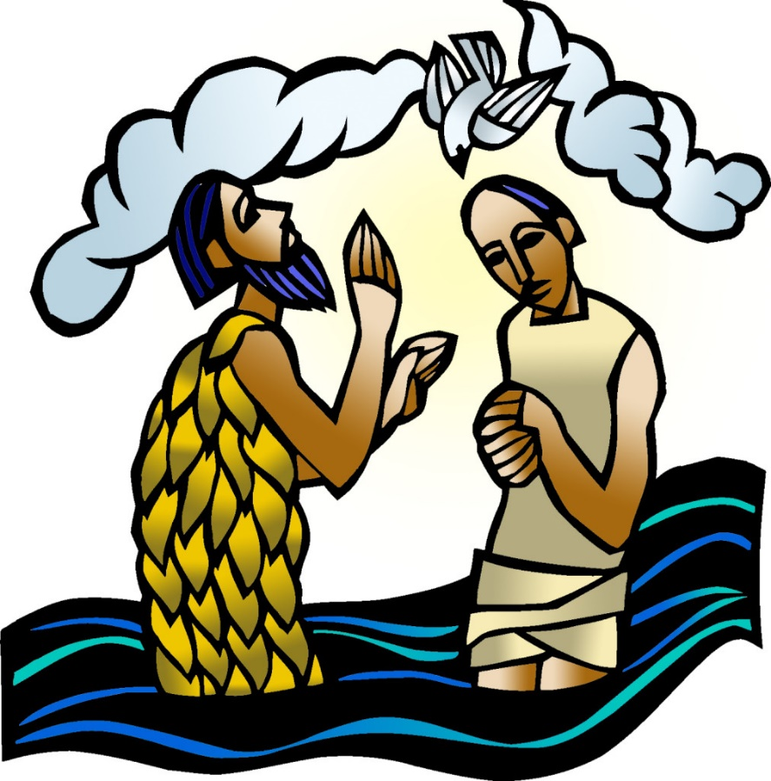

COON VALLEY LUTHERAN CHURCH
Baptism of our Lord
Holy Baptism of Clayton Devere Hansen
Sunday, January 8, 2023

Acolytes: 8:00/Evan Williamson; 10:30/Griffin Nelson
Head Ushers: 8:00/Steve Nelson; 10:30/Jason Thomas
Altar Guild: 8:00/Cindy Swartz, Jane Simmons; 10:30/
Communion Server: 8:00/Steve Pauloski; 10:30/
Readers: 8:00/Mike Lusk; 10:30/Mike Fencl
Attendance & Offering Last Sunday: 9a/41; $2,940.85
Attendance & Offerering from Christmas Services
Dec. 24/107; Dec. 25/54; $7,091.29

SCHEDULE
TODAY: 9:00/Men’s Club Meeting; Constitution Review Forum
MONDAY: 1:00-6:00p/CVC Blood Drive; 6:00p/Finance Committee; Pr. Julie’s Sabbath
TUESDAY: 9:00a/Naomi Circle; South Conf. Pastors; 5:00p/Worship Committee
WEDNESDAY: 9:00a/Quilting; 4:00p/Confirmation
THURSDAY: 6:00p/Church Council
SATURDAY: 11:00a/Lucy Hardie Ordination & Luncheon
SUNDAY: 8:00 & 10:30a/Worship; 9:00a/Sunday School, Coffee Fellowship, Audit Committee Meeting; Carillon Deadline

Coon Valley Lutheran Church
www.coonvalleylutheranchurch.org
Pastor: Rev. Julie Wollman, pastorjuliecvlc@gmail.com Home Phone 634-3797
Office Administrator: Jamie Thomas, jamiel@mwt.net
Office Hours: Tuesday, Wednesday, Thursday 9:00a-2:30p
Office 452-3772/Cell 317-0007
Treasurer: Becky Lusk, treasurer1005@mwt.net
Organist: Mary Schultz
Indoor Custodian: Tracy Stellner

FIRST READING: ISAIAH 42:1-9
Here is my servant, whom I uphold, my chosen, in whom my soul delights; I have put my spirit upon him; he will bring forth justice to the nations. He will not cry or lift up his voice, or make it heard in the street; a bruised reed he will not break, and a dimly burning wick he will not quench; he will faithfully bring forth justice. He will not grow faint or be crushed until he has established justice in the earth; and the coastlands wait for his teaching. Thus says God, the Lord, who created the heavens and stretched them out, who spread out the earth and what comes from it, who gives breath to the people upon it and spirit to those who walk in it: I am the Lord, I have called you in righteousness, I have taken you by the hand and kept you; I have given you as a covenant to the people, a light to the nations, to open the eyes that are blind, to bring out the prisoners from the dungeon, from the prison those who sit in darkness. I am the Lord, that is my name; my glory I give to no other, nor my praise to idols. See, the former things have come to pass, and new things I now declare; before they spring forth, I tell you of them.
The Word of the Lord. Thanks be to God.

PSALM 29 (read responsively)
Ascribe to the Lord, O heavenly beings, ascribe to the Lord glory and strength.
Ascribe to the Lord the glory of his name; worship the Lord in holy splendor.
The voice of the Lord is over the waters; the God of glory thunders, the Lord, over mighty waters.
The voice of the Lord is powerful; the voice of the Lord is full of majesty.
The voice of the Lord breaks the cedars; the Lord breaks the cedars of Lebanon.
He makes Lebanon skip like a calf, and Sirion like a young wild ox.
The voice of the Lord flashes forth flames of fire.
The voice of the Lord shakes the wilderness; the Lord shakes the wilderness of Kadesh.
The voice of the Lord causes the oaks to whirl, and strips the forest bare; and in his temple all say, “Glory!”
The Lord sits enthroned over the flood; the Lord sits enthroned as king forever.
May the Lord give strength to his people! May the Lord bless his people with peace!

SECOND READING: ACTS 10:34-43
Then Peter began to speak to them: ‘I truly understand that God shows no partiality, but in every nation anyone who fears him and does what is right is acceptable to him. You know the message he sent to the people of Israel, preaching peace by Jesus Christ—he is Lord of all. That message spread throughout Judea, beginning in Galilee after the baptism that John announced: how God anointed Jesus of Nazareth with the Holy Spirit and with power; how he went about doing good and healing all who were oppressed by the devil, for God was with him. We are witnesses to all that he did both in Judea and in Jerusalem. They put him to death by hanging him on a tree; but God raised him on the third day and allowed him to appear, not to all the people but to us who were chosen by God as witnesses, and who ate and drank with him after he rose from the dead. He commanded us to preach to the people and to testify that he is the one ordained by God as judge of the living and the dead. All the prophets testify about him that everyone who believes in him receives forgiveness of sins through his name.’
The Word of the Lord. Thanks be to God.

GOSPEL: MATTHEW 3:13-17
Then Jesus came from Galilee to John at the Jordan, to be baptized by him. John would have prevented him, saying, “I need to be baptized by you, and do you come to me?” But Jesus answered him, “Let it be so now; for it is proper for us in this way to fulfill all righteousness.” Then he consented. And when Jesus had been baptized, just as he came up from the water, suddenly the heavens were opened to him and he saw the Spirit of God descending like a dove and alighting on him. And a voice from heaven said, “This is my Son, the Beloved, with whom I am well pleased.”
The Gospel of the Lord. Praise to you, O Christ.

*We are always so happy to include you and our CVLC family in our prayers. If you feel your name, or the name of a family member can be removed from this list please contact Jamie. Thank you!

We remember in prayer:
† Those hospitalized this past week: Gracen Klum
† Our members whose names we lift up in prayer today: Corrine Appleman, Beverly Bagstad, Clifford Bakkum, Inez Beck, Jeanne Ebli, Kira Foster, Lucy Hardie, Bonnie Holey, Donna Ihle, Verlin Ihle, Todd King, Jim Knutson, Paul Kogut, Margaret Lee, Russell Lee, Aaron Leisso, Gerri Leum, Larry Lichtie, Cindy Manske, Aaron Marx, Frank Mathison, Judy Mathison, Bud Miyamoto, Romaine Nelson, Sandy Nelson, Cathy Ofte, Eunice Quast, Jojo Satona, Mary Schultz, Billie Slater, LaVonne Stendahl, Joyce Temp, Teri Tomten
† Our members who are currently in health care facilities & Assisted Living:
Tip Bagstad, Rachel Berg, Evelyn Dahlen, Joanne Fletcher, Erma Graupe, Lenore Henley, Sylvester King Jr., Bob Moilien, Irene Nestingen, Tim Ofte, Beatrice Olson (Alden), Beatrice Olson (Leonard), Betty Sanders, Nancy Stuempges, Arlene Townsend.
† Those who grieve: Family and friends of Sue Frydenlund, Eleanor Bagstad, Paul Kogut, George Navrestad & Lou Ann Engh
† Our members who are currently home-bound
† All those in need of God’s healing and help
† Family and friends of our members
† All those affected by the COVID-19 virus

