| The Carillon | |
| --- | --- |
| Page 1 | September, 2020 |



Dear Siblings in Christ,

Please know you are in my daily thoughts and prayers as we continue to navigate this pandemic time together. Because our space is limited in our newsletter and I have several things I would like to share with you, I will get right to them.

1. **Inside this issue of your Carillon is a Worship Survey**. It is the hope of myself, our council and worship committee that you will share your preferences and thoughts with us regarding worshiping in our Sanctuary. We need your input so that we may put together the best possible plan for scheduling our services, ushers, musicians, cleaning and making sure we are offering the safest environment possible for our worshiping community. Please complete and return the survey **by September 13** in any of these ways: Drop-off the survey in the bin provided outside the Church building; Mail it to the Church Office; complete the survey online either on the Coon Valley Lutheran Church Facebook page, OR on our website [www.coonvalleylutheranchurch.org](http://www.coonvalleylutheranchurch.org).
2. **Depending upon what we learn from the worship surveys, we may need to implement a sign-up for worship services.** Currently, the Coulee COVID-19 Collaborative and the Badger Bounce Back Plan, which we have been following, recommends that no more than 50 people gather indoors, with masking and social distancing, at one time. Our tentative plan, beginning in October, will be to hold two worship services each week to accommodate the needs of our worshiping community. At this time, we are planning to hold one service at 9:00 a.m. on Sundays and one service on Wednesday evenings with a time to be determined. If necessary, a sign-up to reserve one’s space for worship will be made available on our website, Facebook page and by calling the Church Office. If we have a sign-up, we will reserve 25 spaces on Sunday mornings for those who do not have access to online registration and open any of those spaces to others as we are able. The reason for reserving these spaces is to give those who do not have access to online registration plenty of opportunity to call the Parish Office to reserve their worship space*. Please note that this plan is fluid and will change as we discover the needs of our congregation. We will do our absolute best to accommodate everyone with the safety of those most vulnerable as our guide.*

Once the survey results are processed, you will receive a letter outlining the steps for reserving a place at worship. We realize this is not ideal and it is our hope that it will not be something we need to implement for long, but it is where we feel we need to begin.

1. **The reasons for not holding more than one worship service on a Sunday morning** is science. The Center for Disease Control states that the greater the number of people in a shared space over time, the greater the viral load a person may receive. The Wisconsin Council of Churches recommends that Sanctuaries be cleaned 72 hours after a service to allow for the droplets that happen when we speak, settle and that the Sanctuary not be used during that time. This is for the safety of those cleaning as well as those worshiping.
2. **Any plan that is decided upon for Fall worship will include recording our services which will be aired on Facebook, our website and Vernon Communications Channel 15.**

Even as I write this, I realize how overwhelming it may seem. The Coronavirus has changed the way we live and worship. Who would have imagined back in March that we would be worshiping online or contemplating the safety of returning to our sanctuaries for worship?

I have heard it said that if we have enough faith, we will be kept safe from the virus. I have known wonderful, faithful people who have become infected with the Coronavirus and others who were equally faithful who have known other illnesses that have altered their lives. This is not a matter of faith over fear. God has given us the gifts of discerning hearts and minds and scientific research to help us fulfill the calling of caring for the most vulnerable in our midst. I know and trust that God has been at work in our congregation and through our leadership. By God’s grace in these most difficult times we have experienced great and unexpected blessings of faith, hope, and love.

All the decisions that I as your pastor, your staff, council and worship committee members make are made with prayer, thoughtful discussion, research and sometimes tears. We are passionate about our love for Jesus Christ and our love for you. We will get through this time AND emerge a new creation in Christ.

Please complete and return your survey as soon as possible.

With my prayers for you,

Pastor Julie



MCj03226430000[1]JULY CHURCH COUNCIL HIGHLIGHTS

The CVLC Council met on July 9 at 6:00 p.m. Council president Karen Rude called the meeting to order.

*The Treasurer’s Report was presented By Becky Lusk. Offerings for the month were $11,900 and expenses of $11,133 with a positive balance of $766.

*Secretary’s Report: June minutes were reviewed and accepted.

*Ministry Minutes: Pastor Julie reported an outdoor baptism was held. July 12 the service will be on Facebook Live at 9am. A letter was sent to all congregations from Bishop Arends with guidance for offering communion for online services. The youth Mission trip has been cancelled, instead an at home trip is being planned.

*Social Ministry: Cards have been sent out.

MCj02119730000[1]*Building and Grounds: Brian reported that our lighted cross on the front of church will be repaired. Mike & Tom Brye were going to put another coat of paint on the railing to the front church steps. A pew in the balcony has received some sun damage and will be varnished. The garage will be cleaned and organized.

* Discussion Items: Karen Rude led the discussion on holding outdoor worship. Worship will be outside in July unless Vernon county is at severe risk of COVID-19 spread. Social distancing and masks were discussed. New PA equipment was purchased using Memorial funds. A new microphone and cords are still needed. Fall worship plans were discussed. Options included having a Wednesday evening and Sunday morning worship, having people seated by ushers, signage to help with distancing and checking CDC guidelines for cleaning.

WELCA is cancelling the Chili & Chicken Soup Supper.

*Education Committee: Options for Sunday School include virtual classes with 3yr old-2nd graders having packets and online videos. 3rd-6th grade using Zoom meetings. Incorporating children’s sermons during worship could also help. A Sunday School survey will be sent out. VBS registration has begun with Sugar Creek providing at home packets. CVLC Sunday school will pay the $800 for VBS.

*Endowment: The following recommendations for the Endowment distribution were accepted.

20% Ministry of ELCA-Benevolence Payment to Synod- $1,600

20% Capital Improvements-Repair lighted cross, remainder to Building Fund- $1,600

20% Community Outreach-Westby School District delinquent lunch accounts- $1,600

20% CVLC Youth Ministry-2021 National Youth Gathering- $1,600

20% CVLC Youth Ministry- Sugar Creek- $1,600

*The next meeting will be August 20th at 6:00pm.

*The meeting adjourned at 7:35 PM followed by the Lord’s Prayer

Sarah Ofte,

Council Secretary

Thank you to Mike and Tom Brye for painting the front door to the church!

Isabella Grethel, Brian Rude, Janaya and Aaron Stakston, Shianne Reschke and Rachel Strangstalien for sharing their gifts of music during our worship services!

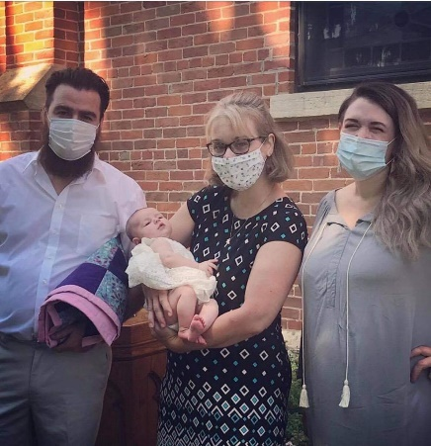BAPTISMS AND NEW MEMBERS

On July 5th we welcomed into our congregation the newly baptized Aurora Ann Glennie! Her parents are Adam and Erin Glennie.

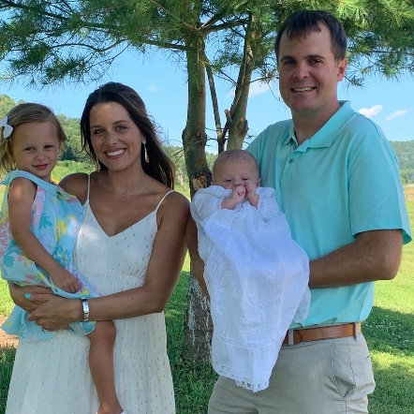On August 16th we welcomed into our congregation Natasha and Collin, Hattie Pearl and Ryker James Olerud who have joined as Associate members!  Ryker was Baptized on August 16.

SUNDAY SCHOOL UPDATE: PLEASE COMPLETE THE SUNDAY SCHOOL SURVEY

A survey created by the Education Committee has been posted on our Church Facebook page, website and has been sent via email to all families for whom we have email addresses. The Education Committee deeply appreciates the responses they have received and hope to receive more in the coming weeks to assist us with Fall planning.

The Education Committee has made the decision to wait until October to begin any kind of Sunday School sessions, in order to give families time to adjust to the new school year. We miss our students and look forward to being able to gather in person or online!

CONFIRMATION UPDATE

Dear families of 7th, 8th, and 9th Grade students,

I will be sending a letter to families of 7th and 8th Grade students of our congregation to seek your input on your comfort level with in-person, virtual or blended (a combination of virtual and in person) Confirmation. I miss gathering with our students and assure you that we will be offering Confirmation ministry (either in person, online or a combination of both) this Fall.

For our 9th Grade students, I will be seeking your input in regard to a service of Affirmation of Baptism (Confirmation). I look forward to celebrating your Affirmation of Faith with you in the Rite of Confirmation!

Please contact me at 634-3797 or [pastorjulie@mwt.net](mailto:pastorjulie@mwt.net) with any questions or concerns.

Thank you!

Pastor Julie

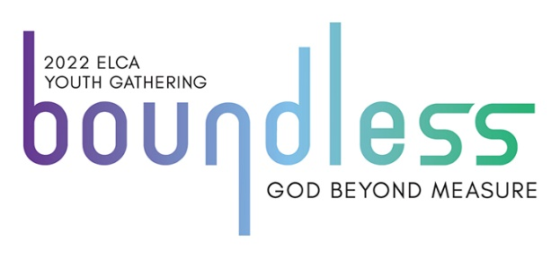

ELCA NATIONAL YOUTH GATHERING POSTPONED

Mark your calendars for July 24-28, 2022!

Due to COVID-19, the ELCA Youth Gathering scheduled for 2021 has been postponed to 2022. The Gathering will still take place in Minneapolis and on the same dates as was scheduled for 2021. All students who will be in 8th through 12th Grade this Fall (2021) are eligible to attend! Registration opens in September so please let Pastor Julie know if you would like to attend or would like to know more about the Gathering! Eligible students can expect to receive more information in September! The Youth Gathering is an event you do not want to miss!

CHILI & CHICKEN SOUP SUPPER CANCELLED

WELCA has decided that their annual Chili & Chicken Soup Supper and raffle will be cancelled this year. They hope to be able to continue this tradition in 2021!

JOIN the WALK or SUPPORT THE HOLY STROLLERS AT THE 2020 SOLE BURNER!

Sole Burner Chaseburg unites the community behind the American Cancer Society's efforts to save lives from cancer. Here's what you can expect:  
   
Date: Saturday, September 19, 2020  
Location: Chaseburg Village Park

To register to walk with the Holy Strollers of Coon Valley Lutheran Church or to make a donation to the walk, please contact Pam Olson at 634-3300 or email Pam at [olsdondp60@gmail.com](mailto:olsdondp60@gmail.com)

If you would like to make a donation towards a basket from our congregation to be donated to the Silent Auction, please direct those to Pam as well.

The registration fee for each walker is a non-refundable $25. Kids are just $15!

Safety is the top priority of the Sole Burner planning team. Masks will be mandatory, there will be one entrance and temperature checks will be made at the entrance.

A Chicken-Q and Soups will be available from 11 a.m.-1:00 p.m. the day of the Sole Burner, with drive-up service available.

Activities throughout the day include (but aren't limited to): Food & Drink Sales, Survivor Recognition, Silent Auction, Live Dessert Auction, Kids Games & Activities, Bounce House, Vendor Sales, Bucket Drawings, Luminaria Ceremony, Cash Prizes, Raffle Tickets & MORE!

The Opening Ceremony starts about 3:00pm and is immediately followed by the walk around the beautiful Chaseburg walking trail.

The live auction will follow.

The evening wraps up with a beautiful and touching Luminaria Ceremony - remembering those touched by cancer. The Closing Ceremony will follow.

DERECHO RELIEF

To give to the relief efforts happening through the Southeast Iowa Synod of the ELCA which is in partnership with Lutheran Disaster Response, you may do so by clicking on the donate button on the Southeastern Iowa Synod website that is available on the Coon Valley Lutheran Church Facebook page

**OR by mail:**

**Southeast Iowa Synod Office**

Northgate Dr, Iowa City, IA 52245

Memo Line: Derecho Relief

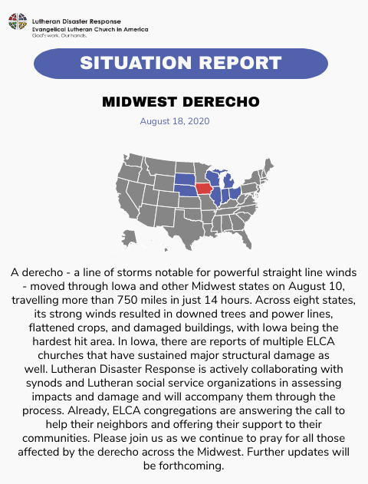100% of your gift will go directly to relief efforts.

BLOOD DRIVE

Thank you to Mike Lusk for coordinating our Blood Drive on August 17th. A total of 54 units of blood was collected at the drive. Thank you also to the many volunteers who help with the drives! Our next blood drive will be on December 7th.

THANK YOU TO ALL WHO PARTICIPATED IN DAY CAMP 2 GO AND OUR AT HOME MISSION TRIP!

DAY CAMP TO GO!

The Theme for our Day Camp 2 GO week was “The Lord’s Prayer.” 15 students from Coon Valley Lutheran joined students from Middle Coon Valley, Lower Coon Valley and Bethel Lutheran Churches for Day Camp 2 GO provided by Sugar Creek Bible Camp!

Students were able to participate with crafts, activities, songs, skits, and Bible stories presented through a combination of videos and paper handouts. Families picked up their Day Camp 2 Go Gift Bags from Pastor Meg Hoversten and Pastor Julie through a Drive-through Pick-up and participated when it was convenient for them. Thank you to our Sunday School for providing this opportunity and Maggie Traastad and Jamie Thomas for getting the materials prepared for our students!

SUBSCRIBE TO OUR NEWSLETTER

Would you like to receive our newsletter via email? This saves the church money on the cost of office supplies and postage. If you would like to subscribe visit our website at [www.coonvalleylutheranchurch.org](http://www.coonvalleylutheranchurch.org) scroll to the bottom of the page and enter your full name and email. That’s it! Thank you!

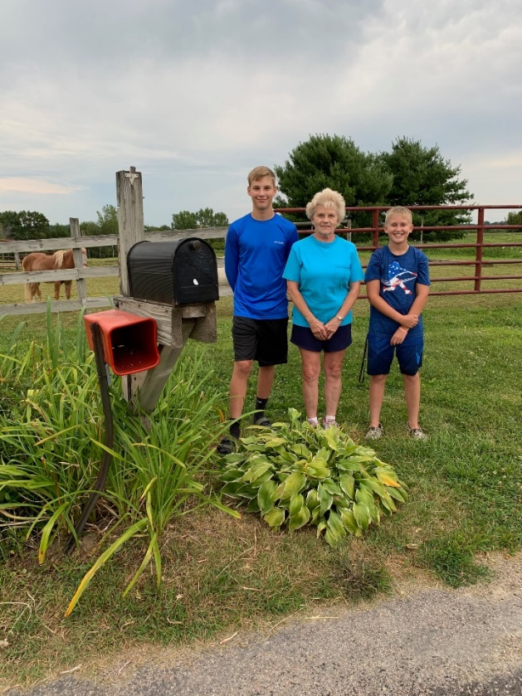MISSION TRIP AT HOME!

Many thanks to Casey Brye who made our first-ever Mission Trip at Home a fun success! Our theme for our Mission Trip was “First Love” based on 1 John 4:19, “We love because God first loved us.” YouthWorks provided us with free devotional resources to share with our 8 students who participated in the Mission Trip from Home. Each of our students received a gift bag with snacks, a devotional book, a Thrivent T-Shirt, and some other fun items that were chosen just for them.

The gift bags and contents were made possible by Thrivent Action Team funds which Kim and Tim Hatlan secured for our youth. Students did yard work for neighbors, made beautiful cards for our members, and assisted their family and neighbors in other ways. Each of the four nights a devotional was shared on our Church Facebook page by Casey Brye, Shianne Reschke, Nancy Rogers, and Pastor Julie.

Thank you to all who made these events possible and supported us with your prayers!

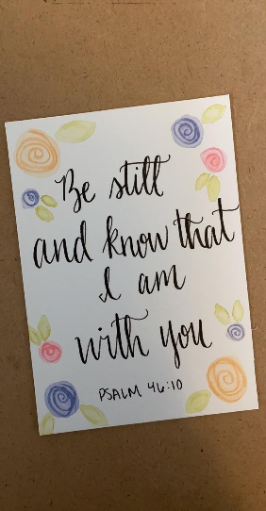 Cards made by Bree Hatlan to send to members.

(Pictured above: Blake Hatlan, Linda Servais and Chase Quellhorst.)

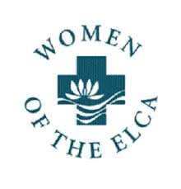WELCA NEWS

Dear WELCA Sisters,

Looking back through the articles I’ve written this summer, I wrote in the June letter that the leaves were on the trees-fast forward to now and the leaves are either starting to change color or are falling off the trees. We may be having a hard time adjusting to all the changes but Mother Nature just keeps rolling along doing what she does year after year.

With September around the corner, I just want to remind you that there will be no Morning Coffee after church, no WELCA meeting and no Chili & Chicken soup supper.

There is a tote to put school supplies in and, once again, if you are out shopping please consider purchasing school supplies for the students at Coon Valley Elementary School.

Even though we are not meeting during this time, we still need to know who is in your Circle, if you are or are not planning to stay on a committee that you’re currently serving on, if you plan to keep the office you’re holding, etc. This is all information we need for the 2021 Yearbook. At some point, the officers will have to get together to plan whether or not there will be a cookie walk and a Christmas Brunch.

Even though our world has changed-it has not stopped. Hopefully, you are keeping in touch via texts, e-mails, phone calls and written notes. I wish you all well and hope to see you at a meeting soon.

God Bless, Ellie Brye, President

Quote by Maya Angelou

She said, “I’ve learned that whenever I decide something with an open heart, I usually make the right decision. I’ve learned that even when I have pains, I don’t have to be one. I’ve learned that every day you should reach out and touch someone. People love a warm hug, or just a friendly pat on the back. I’ve learned that I still have a lot to learn. I’ve learned that people will forget what you said, people will forget what you did, but people will never forget how you made them feel.”

GIVING OPTIONS

If you are not yet able or not comfortable coming to in-person worship we have several options for you to get your offerings to the church. You may simply mail it to the church office, P.O. Box 280. Or use one of our eGiving options. 1) You may go to our website and click the Donate button at the top. 2) Give through the mobile app Give Plus. 3) Use our text-to-give option, simply text a dollar amount to 866-374-6997. Please let Jamie know if you need assistance in any way with these options. Thank you for your support!



KWIK TRIP GIFT CARDS SUPPORT CVLC YOUTH

Remember to purchase Kwik Trip cards! We are able to purchase these cards for a discount, plus an additional 10% of in-store purchases is given to the church Youth Fund. Purchase them as gifts for those heading to college, to tell someone thank you or purchase to use for your own needs including gas, milk, bread and much more. Call Jamie to sign up 317-0007 or email [jamiel@mwt.net](mailto:jamiel@mwt.net). An order will be placed at the end of each month. Help us support our CVLC Youth!



SUGAR CREEK BIBLE CAMP

**Annual Quilt Auction, 5k Fun Run/Trail Walk & Craft Fair**

**September 12 @ 8:00am - 2:00pm**

Beautiful Quilts, Antiques, Sports memorabilia, Crafts, Gift Baskets & so much more! BBQ pork lunch, pies and delicious treats! Come enjoy and support Sugar Creek!

**ATTENDANCE & OFFERING**

|  |  |  |  |
| --- | --- | --- | --- |
| **2020** | **July** |  | **2020 YTD** |
| **Total Offerings** | $13,806.00 |  | $99,586.68 |
| **Expenses** | $11,548.95 |  | $97,685.69 |
| **Balance/Shortfall** | **$2,257.05** |  | **$1,900.99** |
| **Parsonage Int. Fund Transfer** | $0 |  | $0 |
| **Building Fund Transfer** | $0 |  | $1,300.00 |
| **Memorial Fund**  **Transfer** | $0 |  | $1,399.98 |

**7/26 -** **Offering:** $1,801.24

**8/2 - 9am/72; 11am/21=93 total**

**Offering:** $4,862.24

**8/9 - 9am/84; Offering:** $3,356.24

**8/16 - 9am/78; Offering:** $3,102.24

**8/23 – 9am/98; Offering:** $5,341.24

**\*\***Approximately **$3,800.00 a week** is needed to meet operating expenses.

**General Fund Balance:** 7/31/20: $29,610.77

**Memorial Fund Balance:**7/31/20: $33,360.58

**Building Fund Balance:** 7/31/20: $4,563.72

**CD Interest Balance:** 7/31/20: $17,647.08

BAPTISM

8/16 Ryker James Olerud

FUNERAL

8/8 Jack Fletcher

MEMORIALS

**Arvid Holey**

Memorial Fund: $50.00

**Ronald Olson**

Memorial Fund: $460.00

**Jack Fletcher**

Memorial Fund: $10.00

**Kay Swiggum**

Memorial Fund: $25.00

BUILDING USE

At this time only church staff and officers are permitted in the church building. If you are there during office hours please ring the doorbell and Jamie will assist you at the door. Thank you for understanding. 😊

Doing your shopping on **Amazon**? Please go to

[www.smile.amazon.com](http://www.smile.amazon.com), enter ***Coon Valley Congregation*** do your shopping and **Amazon Smile** will donate a small percentage to our church!

**YEAR-TO-DATE BALANCE**

PRAYER GROUP

The Prayer Group continues to pray for the church, the congregation and our extended family and friends.

**† *Our church staff***

**† *Our members*:** Beverly Bagstad, Eleanor Bagstad, Tip Bagstad, Clifford Bakkum, Inez Beck, Kay Bjornstad, Evelyn Dahlen, Judy Denison, Jeanne Ebli, Kira Foster, Lucy Hardie, Bonnie Holey, Verlin Ihle, Jim Knutson, Elizabeth Larson, Russell Lee, Aaron Leisso, Sarah Leisso, Gerri Leum, Becky Lind, Cindy Manske, Aaron Marx, Skyler Midtlien, Romaine Nelson, Cathy Ofte, Tim Ofte, Sherman Olson, Steve Pauloski, Eunice Quast, Jojo Satona, Aaron Stakston, Terri Stakston, LaVonne Stendahl, Orville Stendahl, Nancy Stuempges, Ray Williamson.

**† *Our members who are currently in health care facilities*:** Sylvester King Jr., Irene Larson, Irene Nestingen, Beatrice Olson (Alden), Beatrice Olson (Leonard), Edie Peterson.

**† *Those who grieve:*** Steve Pauloski and family in the death of his mother Connie Pauloski, Joanne Fletcher and family in the death of Jack, Bonnie Holey & family in the death of Arvid, Barry & Karen Bergum in death of Barry’s sister Gail Donovan. Beatrice (Leonard) Olson in the death of her son Ronald Olson.

**† *Family and friends of members***

**† *Local Military:***Austin Holen, and John Nelson

**† *All those affected by the COVID-19 virus***

**COON VALLEY LUTHERAN CHURCH CONGREGATIONAL WORSHIP SURVEY**

Our council, worship committee and Pastor Julie are seeking your guidance in making plans for our Fall worship services. **Please complete one survey per household**. You may complete this survey and return it to the Parish Office either by mail or by placing it in the dropbox outside the building. The survey is also available to complete on our website: [www.coonvalleylutheranchurch.org](http://www.coonvalleylutheranchurch.org) or on the Coon Valley Lutheran Church Facebook page.

**Please complete and return the survey by Sunday, September 13.Thank you!**

1. If indoor services were to begin in October, with mandatory masks and social distancing would you attend?

__YES

__NO

1. If you answered “No” to question #1, under what circumstances would you feel comfortable attending

an indoor worship service?

1. Since March, how have you participated in our worship services? (Please check all that apply):

__Worship on the Lawn

__You Tube Video/Facebook/CVLC Website

__Vernon Communications Cable TV

__Worship by Mail

__I have not been participating in worship

__Other

1. If indoor services are held, we anticipate that we will need to limit the number of attendees and hold two services. One service would be held at 9:00 a.m. Sunday morning and one on Wednesday evening. Those planning to attend worship will need to sign-up in advance of the service. If a Sunday morning service is “Full” via a Sign-Up, would you be willing/able to attend a Wednesday evening service?

__YES

__NO

1. What is your time preference for a Wednesday evening service: Please check one:

__6:00 p.m.

__7:00 p.m.

1. Any other thoughts regarding worship at Coon Valley Lutheran Church you would like to share at this time?

**Thank you for taking the time to share your thoughts with us!**

**Please use the reverse side of the sheet for any additional notes**

**you wish to share with our leadership.**

**DAILY BIBLE READINGS**

**WEEK OF SEPTEMBER 6**

**SUNDAY** Ezekiel 33:7-11 *The prophet’s responsibility*

Psalm 119:33-40 *The path of your commandments*

*or* Exodus 12:1-14 *The passover*

Psalm 149 *Sing praise in the congregation*

Romans 13:8-14 *Live honorably as in the day*

Matthew 18:15-20 *reconciliation in the community of faith*

**MONDAY** Leviticus 4:27-31, 5:14-16 *Atoning for sin in the community*

**TUESDAY** Deuteronomy 17:2-13 *Punishment for sin in the community*

**WEDNESDAY** Matthew 21:18-22 *Jesus teaches about communal prayer*

**THURSDAY** Leviticus 16:1-5, 20-28 *The scapegoat cleanses the community*

**FRIDAY** Romans 13:1-7 *Obeying authority*

**SATURDAY** Psalm 119:65-72 *The law humbles me*

**WEEK OF SEPTEMBER 13**

**SUNDAY** Genesis 50:15-21 *Joseph reconciles with his brothers*

Psalm 103[1-7] 8-13 *The LORD is full of compassion and mercy*

*or* Exodus 14:19-31 *Israel’s deliverance at the Red Sea*

Psalm 114 *Tremble, O earth*

Or Exodus 15:1b, 20-21 *The LORD triumphed gloriously*

Romans 14:1-12 *Diversity in the community of faith*

Matthew 18:21-35 *A parable of forgiveness*

**MONDAY** Genesis 37:12-36 *Joseph’s brothers sin against him*

**TUESDAY** Genesis 41:53—42:17 *Joseph acts harshly against them*

**WEDNESDAY** Matthew 6:7-15 *Forgiving one another*

**THURSDAY** Genesis 45:1-20 *Joseph forgives his brothers*

**FRIDAY** Romans 14:13—15:2 *Building each other up*

**SATURDAY** Psalm 133 *How good it is to live in unity*

**WEEK OF SEPTEMBER 20**

**SUNDAY** Jonah 3:10—4:11 *God’s concern for Nineveh*

Psalm 145:1-8 *The LORD is slow to anger*

*or* Exodus 16:2-15 *Manna and quails in the wilderness*

Psalm 105:1-6, 37-45 *Remembering the wilderness*

Philippians 1:21-30 *Standing firm in the gospel*

Matthew 20:1-16 *The parable of the vineyard workers*

**MONDAY** Genesis 27:1-29 *The younger son gets the blessing*

**TUESDAY** Genesis 28:10-17 *God blesses the runaway Jacob*

**WEDNESDAY** Matthew 19:23-30 *The last will be first*

**THURSDAY** Isaiah 41:1-13 *God will be with the last*

**FRIDAY** Romans 16:1-20 *Workers in the church of Rome*

**SATURDAY** Psalm 106:1-12 *God’s mercy*

**WEEK OF SEPTEMBER 27**

**SUNDAY** Ezekiel 18:1-4, 25-32 *The fairness of God’s way*

Psalm 25:1-9 *God’s compassion and love*

*Or* Exodus 17:1-7 *Water from the rock*

Philippians 2:1-13 *Christ humbles to the pint of death*

Matthew 21:23-32 *A parable of doing God’s will*

**MONDAY**Judges 16:1-22 *Samson asked about his strength*

**TUESDAY** Judges 16:23-31 *Samson prays to do God’s will*

**WEDNESDAY** Matthew 9:2-8 *Jesus’ authority*

**THURSDAY** Joshua 4:1-10, 19-24 *Joshua leads the people God’s way*

**FRIDAY** Philippians 1:3-30 *Proclaiming Christ*

**SATURDAY** Psalm 28 *Prayer to do God’s will*