COON VALLEY LUTHERAN CHURCH
“We are a family of God, striving to enrich
the lives of all through the love of Christ.”

PRELUDE MUSIC
~ GATHERING ~
The Holy Spirit calls us together as the people of God

WELCOME and ANNOUNCEMENTS

CONFESSION and FORGIVENESS
In the name of the Father, and of the +Son, and of the Holy Spirit. Amen.

Almighty God, to whom all hearts are open, all desires known, and
from whom no secrets are hid: Cleanse the thoughts of our hearts by
the inspiration of your Holy Spirit, that we may perfectly love you
and worthily magnify your holy name, through Jesus Christ our Lord. Amen.

Let us confess our sin in the presence of God and of one another.
(Time for reflection and self-examination)

Most merciful God,
We confess that we are captive to sin and cannot free ourselves. We
have sinned against you in thought, word, and deed, by what we
have done and by what we have left undone. We have not loved you
with our whole heart; we have not loved our neighbors as ourselves.
For the sake of your Son, Jesus Christ, have mercy on us. Forgive us,
renew us, and lead us, so that we may delight in your will and walk
in your ways, to the glory of your holy name. Amen.

In the mercy of almighty God, Jesus Christ was given to die for us,
and for his sake God forgives us all our sins. As a called and ordained
minister of the church of Christ, and by His authority, I therefore
declare to you the entire forgiveness of all your sins, in the name of
the Father, and of the +Son, and of the Holy Spirit. Amen.

HYMN of PRAISE ELW #764 Have No Fear, Little Flock

GREETING and PRAYER of the DAY
The grace of our Lord Jesus Christ, the love of God, and the communion of the Holy Spirit be with you all. And also with you.

Almighty God, you sent your Holy Spirit to be the life and light of your Church. Open our hearts to be filled with your Spirit and led by your grace, that we may be ready to serve you, through Jesus Christ, our Savior and Lord. Amen.

~ WORD ~
God speaks to us in scripture reading, preaching, and song
FIRST READING: Genesis 15:1-6
PSALM 33:12-22 (read responsively)
SECOND READING: Hebrews 11:1-3, 8-16
GOSPEL: Luke 12:22-40
The Word of the Lord. Thanks be to God.

SERMON

HYMN of the DAY SOLO Simple Gifts Mary Schultz

~ RESPONSE TO THE WORD ~
The Holy Spirit calls us as a community to say what we believe,
reach out to each other, and offer gifts and prayers for God’s purposes

PRAYERS of INTERCESSION
Petitions end: Merciful God…receive our prayer.

OFFERING/OFFERTORY PRAYER
In the offering of our gifts, as well as the living of our days,
may we not grow weary of doing what is right, but commit to speaking up for the voiceless, healing the broken, feeding the hungry, and all those mercies which are such a part of your heart and hopes for all your children. In Jesus’ name, we pray. Amen.

~ SENDING ~
God blesses us and sends us in mission to the world
THE GREAT THANKSGIVING
The Lord be with you. And also with you.
Lift up your hearts. We lift them to the Lord.
Let us give thanks to the Lord our God.
It is right to give him thanks and praise.

THE WORDS of INSTITUTION

THE LORD’S PRAYER
Our Father who art in heaven, hallowed be thy name, thy kingdom come, thy will be done, on earth as it is in heaven.
Give us this day our daily bread; and forgive us our trespasses,
as we forgive those who trespass against us;
and lead us not into temptation, but deliver us from evil.
For thine is the kingdom, and the power, and the glory,
forever and ever. Amen.

COMMUNION SOLO Mary Schultz

POST-COMMUNION BLESSING

BENEDICTION

BELLS

SENDING HYMN ELW #536 God, Be With You ‘Til We Meet Again

DISMISSAL Go in peace. Serve the Lord! Thanks be to God!

POSTLUDE Mary Schultz

0000000000000000000000000000000000

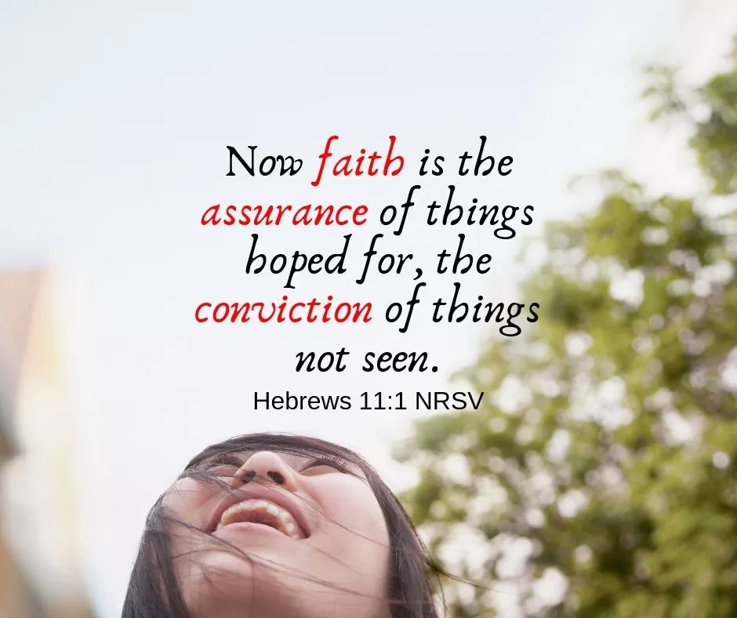

COON VALLEY LUTHERAN CHURCH
August 7, 2022
Ninth Sunday in the Season of Pentecost

~Bulletins are in honor of Ellie Brye’s 80th birthday from her family.

Head Usher: Mike Lusk
Reader: Ron Moilien
Altar Guild: Cindy Swartz
Communion Server: Ray Williamson

SCHEDULE

TODAY: 5:15-7:00p/Vacation Bible School

MONDAY: 5:15-7:00/Vacation Bible School

TUESDAY: 5:00-7:30/Community Corn Roast; 5:00/Vacation Bible School; 6:00p/ Vacation Bible School Closing Program

WEDNESDAY: 9:00a/Quilting

THURSDAY: 6:00p/Church Council

NEXT SUNDAY: 9:00a/Worship with Holy Communion; Coffee Fellowship provided by Naomi Circle

Coon Valley Lutheran Church
www.coonvalleylutheranchurch.org
Pastor: Rev. Julie Wollman, pastorjuliecvlc@gmail.com Home Phone 634-3797
Office Administrator: Jamie Thomas, jamiel@mwt.net
Office Hours: Wednesday & Thursday 9:00a-4:00p
Office 452-3772/Cell 317-0007
Treasurer: Becky Lusk, treasurer1005@mwt.net
Organist: Mary Schultz
Indoor Custodian: Tracy Stellner

FIRST READING: GENESIS 15:1-6
After these things the word of the Lord came to Abram in a vision, “Do not be afraid, Abram, I am your shield; your reward shall be very great.”
But Abram said, “O Lord God, what will you give me, for I continue childless, and the heir of my house is Eliezer of Damascus?” And Abram said, “You have given me no offspring, and so a slave born in my house is to be my heir.” But the word of the Lord came to him, “This man shall not be your heir; no one but your very own issue shall be your heir.” He brought him outside and said, “Look toward heaven and count the stars, if you are able to count them.” Then he said to him, “So shall your descendants be.” And he believed the Lord; and the Lord reckoned it to him as righteousness.
The Word of the Lord. Thanks be to God.

PSALM 33:12-22 (read responsively)
Happy is the nation whose God is the Lord, the people whom he has chosen as his heritage.
The Lord looks down from heaven; he sees all humankind.
From where he sits enthroned he watches all the inhabitants of the earth—he who fashions the hearts of them all, and observes all their deeds.
A king is not saved by his great army; a warrior is not delivered by his great strength.
The war horse is a vain hope for victory, and by its great might it cannot save.
Truly the eye of the Lord is on those who fear him, on those who hope in his steadfast love,
to deliver their soul from death, and to keep them alive in famine.
Our soul waits for the Lord; he is our help and shield.
Our heart is glad in him, because we trust in his holy name.
Let your steadfast love, O Lord, be upon us, even as we hope in you.

SECOND READING: HEBREWS 11:1-3, 8-16
Now faith is the assurance of things hoped for, the conviction of things not seen. Indeed, by faith our ancestors received approval. By faith we understand that the worlds were prepared by the word of God, so that what is seen was made from things that are not visible. By faith Abraham obeyed when he was called to set out for a place that he was to receive as an inheritance; and he set out, not knowing where he was going. By faith he stayed for a time in the land he had been promised, as in a foreign land, living in tents, as did Isaac and Jacob, who were heirs with him of the same promise. For he looked forward to the city that has foundations, whose architect and builder is God. By faith he received power of procreation, even though he was too old—and Sarah herself was barren—because he considered him faithful who had promised. Therefore from one person, and this one as good as dead, descendants were born, “as many as the stars of heaven and as the innumerable grains of sand by the seashore.” All of these died in faith without having received the promises, but from a distance they saw and greeted them. They confessed that they were strangers and foreigners on the earth, for people who speak in this way make it clear that they are seeking a homeland. If they had been thinking of the land that they had left behind, they would have had opportunity to return. But as it is, they desire a better country, that is, a heavenly one. Therefore God is not ashamed to be called their God; indeed, he has prepared a city for them.
The Word of the Lord. Thanks be to God.

GOSPEL READING: LUKE 12:22-40
He said to his disciples, “Therefore I tell you, do not worry about your life, what you will eat, or about your body, what you will wear. For life is more than food, and the body more than clothing. Consider the ravens: they neither sow nor reap, they have neither storehouse nor barn, and yet God feeds them. Of how much more value are you than the birds! And can any of you by worrying add a single hour to your span of life? If then you are not able to do so small a thing as that, why do you worry about the rest? Consider the lilies, how they grow: they neither toil nor spin; yet I tell you, even Solomon in all his glory was not clothed like one of these. But if God so clothes the grass of the field, which is alive today and tomorrow is thrown into the oven, how much more will he clothe you—you of little faith! And do not keep striving for what you are to eat and what you are to drink, and do not keep worrying. For it is the nations of the world that strive after all these things, and your Father knows that you need them. Instead, strive for his kingdom, and these things will be given to you as well. “Do not be afraid, little flock, for it is your Father’s good pleasure to give you the kingdom. Sell your possessions, and give alms. Make purses for yourselves that do not wear out, an unfailing treasure in heaven, where no thief comes near and no moth destroys. For where your treasure is, there your heart will be also. “Be dressed for action and have your lamps lit; be like those who are waiting for their master to return from the wedding banquet, so that they may open the door for him as soon as he comes and knocks. Blessed are those slaves whom the master finds alert when he comes; truly I tell you, he will fasten his belt and have them sit down to eat, and he will come and serve them. If he comes during the middle of the night, or near dawn, and finds them so, blessed are those slaves. “But know this: if the owner of the house had known at what hour the thief was coming, he would not have let his house be broken into. You also must be ready, for the Son of Man is coming at an unexpected hour.”
The Word of the Lord. Thanks be to God.

*We are always so happy to include you and our CVLC family in our prayers. If you feel your name, or the name of a family member can be removed from this list please contact Jamie. Thank you!

We remember in prayer:
† Those hospitalized this past week
† Our members whose names we lift up in prayer today: Corrine Appleman, Beverly Bagstad, Eleanor Bagstad, Tip Bagstad, Clifford Bakkum, Inez Beck, Brian Berg, Darin Berg, Ellie Brye, Jeanne Ebli, Kira Foster, Lucy Hardie, Bonnie Holey, Donna Ihle, Verlin Ihle, Todd King, Jim Knutson, Paul Kogut, Margaret Lee, Russell Lee, Aaron Leisso, Gerri Leum, Larry Lichtie, Cindy Manske, Aaron Marx, Frank Mathison, Judy Mathison, Bud Miyamoto, Romaine Nelson, Corrine Nelson, Sandy Nelson, Cathy Ofte, Steve Pauloski, Eunice Quast, Jojo Satona, Mary Schultz, Billie Slater, LaVonne Stendahl, Joyce Temp, Teri Tomten
† Our members who are currently in health care facilities: Rachel Berg, Evelyn Dahlen, Joanne Fletcher, Betty Gilbertson, Erma Graupe, Gloria Graupe, Dennis Holen, Sylvester King Jr., Glen Marshall, Bob Moilien, Irene Nestingen, Tim Ofte, Beatrice Olson (Alden), Beatrice Olson (Leonard), Betty Sanders, Nancy Stuempges, Arlene Townsend.
† Those who grieve
† Our members who are currently home-bound
† All those in need of God’s healing and help
† Family and friends of our members
† All those affected by the COVID-19 virus

